E-NOTE FOR CHEMISTRY SS1

**SCHEME OF WORK FOR SECOND TERM SS1 CHEMISTRY.**

**WEEKS TOPICS**

1. **REVISION OF FIRST TERM /INTRODUCTION TO MOLE CONCEPT.**
2. **CALCULATIONS IN TERMS OF AVOGADRO’S CONSTANT,EMPIRICAL FORMULA AND MOLECULAR FORMULA**
3. **WRITING AND BALANCING OF CHEMICAL EQUATIONS.**

**4&5 STATE, ILLUSTRATIONS AND VERIFICATION OF CHEMICAL LAWS.**

**6. CHEMICAL COMBINATIONS OR BONDING.**

**7. THE KINETIC THEORY OF MATTER.**

**8. GAS LAWS AND CALCULATIONS.**

**9. GAY-LUSSAC’S LAW**

**10. AIR & FLAME.**

**WEEK 1**

**INTRODUCTION TO MOLE CONCEPT**

Matter is defined as anything that has mass and occupies space it is made up of discrete of tiny particles such as atoms, molecules and ions.

**ATOM:** This is the smallest particle of an element which can participate/take part in a chemical reaction. E.g., O, N, F, S, Cl, Na, He etc.

NOTE: Atoms cannot exist separate.

**MOLECULE**: This is the smallest particle of a substance that is capable of independent existence and still retains the chemical properties of that substance. Examples H2, 02, F2, S8, Cl2, H2O, NaCl etc.

NOTE: A molecule is formed when two or more atoms are chemically joined together. The combination of atoms of the same type produces molecules of an element while the combination of different types of atoms produce molecule of a compound. The molecule does not lose its identity.

**ATOMICITY**: This is the number of atoms in a molecule of an element, most gaseous elements are diatomic. Examples comprise of noble gases and metals respectively. Example He, ,Ar, Ne, Ca, Mgetc.P4 tetra atomic element 03 triatomic element S8 polyatomic element.

**IONS:** These are atoms or group of atoms which possesses an electric charge. There are two types of ions namely:

i. **Cations** which results from the loss of electrons by the atom of a metal to become positively charge. Example, K+, Na+, Ca2+, Al3+, Cr3+, Ag+, Pb2+, NH4+

ii. **Anions** which results from the gain of electrons by the atom of non metal to become negatively charge. Example 0-2, Cl-, F-, S-2, N-3, 0H-, S042-, Cr2072-, MnO4- etc.

**RELATIVE FORMULAE MASS**

The relative formulae mass of a substance can be defined as the number of times the mass of one

Formulae unit of the substance is heavier than one twelfth of the mass of one atom of carbon 12

i.e.

**RELATIVE FORMULAE MASS**

Mass of 1 formulae unit of a substance 1/12 x mass of atom of Carbon -12.

**RELATIVE ATOMIC MASS (RAM)**

The relative atomic mass (RAM) of an element is the mass of one atom of the element. R.A.M

not a whole number because of the existence of the phenomenon of isotopy.

NOTE: R.A.M has no unit.

**DEFINITION:**

The relative atomic mass of an element can be defined as the number of times the average mass

Of atom of the element is heavier than one twelfth of the mass of one atom of carbon-12.

R.A.M.=mass of I atom of the element

1/12 x mass of I atom of carbon

NOTE:

a. Carbon is used as a standard

b. The instrument used for measuring relative atomic mass is called **mass spectrometer**

**RELATIVE MOLECULAR MASS** (Mr/Rmm) of a substance is the mass of one molecule of the substance. The r.m.m. is the sum of the R.A.M. of all the atoms present in the molecule.

NOTE: The r.m.m has no unit.

**DEFINITION**

The relative molecule mass of an element or a compound is the number of time the mass of one

Molecule of the element or compound is heavier than one twelfth of the mass of one atom of

Carbon-12.

R.m.m. = Mass of 1molecule of substance

1/12 x mass of atom of carbon -12

= mass of 1 molecule of substance x 12

Mass o atom of carbon -12

**Example**

1. Calculate the relative molecular masses of each of the following

a) H2S04 (b) Al2 (S04) 3

c) Fe S04 7H20

(H=1, S=32, 0=16, Al=27, Fe = 56)

**SOLUTION**

1. = 2 H + 1S + 40

= 2 x 1 + 32 + 4 x 16

2 + 32 + 64 = 98

b. Al2 (S04)3

= 2Al + 3S + 12 0

= (2x27) + (3x32) + (12x16)

54 + 96 + 192

= 342

c. FeS04. 7H20

= Fe+ S+40 + 7 (2H+0)

= 56 + 32 + (4x16) + (7x18)

= 56 + 32 + 64 + 126

= 278

**Exercises**

Calculate the R.m.m. of the following compounds

i. Calcium hydroxide Ca (OH) 2

ii. Lead (ii) trioxonitrate Pb (N03)2

iii. Ammoniumtrioxocarbonate (IV) (NH4)2C03

iv. Iron (IV) tetraoxo sulphate (VI) Fe2 (S04)3

v. FeS04.Al2 (S04)3.12H20

(R.a.m = Ca=40, 0=16, H=1,Pb = 207, N=14, C=12, Al=27, S=32, Fe =56)

**MOLE**

The mole can be defined as the amount of substance which contains Avogadro’s number of particles. The particles may be of different kinds, which may be atoms, molecules, ions, electrons, protons neutrons etc. Hence it is very necessary to state the type of particle involved.

NOTE:

. Mole is a unit of measurement

. The Avogadro’s number is constant and the value is **6.02 x1023** atoms or molecules or ions or electrons or protons or neutrons etc.

. For a reaction to occur, the particles of reactants must come together to form certain number of particles of product.

. Very large numbers of particles are to be worked with; hence it is difficult to measure individual particles in the reaction. To this effect, a unit for measuring the amount of particles in a given mass of a substance is designed and this is called a MOLE.

. From experimental work, it was found that 1 mole of substance = **6.02 x 1023** particles. This number is called **AVOGADRO’S NUMBER.**

. Therefore, a mole of any substance is the amount of that substance that contains the Avogadro’s number. Example just as 1 dozen of egg = 12 eggs so is 1 mole of oxygen

atoms contain 6.02 x 1023 oxygen atoms.

. 302 moles of oxygen molecules or 6 moles of oxygen atoms.

. 3MgS04 = 3 moles of MgS04 molecules or 3 moles of magnesium atom, 3 moles of sulphur atoms and 12 mole of oxygen atoms.

. 2H2 + 02 2H20 2moles of hydrogen molecules reacts with 1 mole of oxygen molecule to produce 2 moles of water.

**MOLAR MASS**

The mass of one mole of any substance expressed in grams unit = g/mol

Examples:

Chlorine gas (Cl2)

= 35.5 x 2, = 71g /mole

Carbon dioxide gas (C02)

= 12 + (16 x 2) = 44g/mol

**THE MOLE CONCEPT**

The mole can be expressed in the following ways:

i. The mole in terms of formula

ii. The mole in term of relative molecular man (R.A.M)

iii. The mole in terms of Avogadro’s number

The mole in term of the molar volume

NOTE: The expression of the mole in different ways mentioned above is known as the MOLE CONCEPT.

A. MOLE IN TERMS OF THE FORMULA

The mole can be expressed as:

Element: Mole = mass of the element

* Relative Atomic Mass of Element

OR

Compound: = Mole mass in grams

Or molecule R.M.M

Example:

Calculate the number of moles of atoms, present in 40g of calcium carbonate or calciumtrioxo

Carbonate (IV) (CaC03)

**Solution:**

Mass of CaC03 = 40g

R.M.M. CaC03 = (40 + 12 +16)

= 100glmol

Mole (n) = Mass is g

R.M.M CaC03

N = 40g

100g/mole

= 0.4 mole

**QUESTION**

1.A molecule is the smallest particle of

(A) a matter that can exist in Free State

(B) an element that can exist in Free State

(C) a radical that can exist in Free State

(D) a lattice that can exist in Free State

2. 3NH3 is

(A) three moles of ammonium

(B) three moles of ammonia

(C) six moles of ammonia

(D) six moles of ammonium

1. How many moles of substance are present is

a. 35g of oxygen gas (02)

b. 140g of sodium chloride (NaCl)

c. 150g of carbon dioxide gas (C02)

(0 – 16, Na = 23, C1 = 35.5, C =12)

2. Calculate the grams molecular mass for the following compounds

(a) Na2C03 (b) H3 P04

(c) Fe2 (S04)3 (d) Al2 03

(Ca = 40, C=16, H = 1,

P=31, Fe = 56, S =32, Al = 27)

3.Determine the number of grammes of substance contained in 0.5 moles of hydrogen chloride gas (HCl) (Cl=35.5, H=1).

**WEEK 2**

**MOLE IN TERMS OF THE RELATIVE ATOMIC MASS OR RELATIVE MOLECULAR MASS OF ASUBSTANCE.**

The mole can be expressed in terms of the R.A.M of an element or the R.M.M. of a substance/molecule/compound this:

1 mole of any substance = the R.A.M. of the substance or the R.M.M of the substance.

NOTE:

1 mole of Na (g) = 23g mole

1 mole of 02 (aq) = 16g mole

1 mole of 02 (g) = 16 x 2 = 32glmol

1 mole of C02 (g) = 12 + 16 x 2 = 44g1mol

1 mole of H2S04 (aq) = (2 x 1) + 32 +64 = 98glmol

Example:

1. Calculate the number of moles present in 11g of carbon dioxide or carbon (iv) oxide (C02) gas

**Solution:**

1 mole C02 (g) = Rmm of C02 (g)

1 mole of C02 = 12 + (16x2) = 44g g/mol

:. 44g of C02 = 1 mole of C02 (g)

1 g of C02 = 1/44 mole of C02 (g)

:. 11g of C02 = 1/44 x 11 mole of C02 (g)

= 0.25 mole of C02 (g)

* Determine the number of grammes of substance present in 0.05 of sodium carbonate (sodium trioxocarboante IV) (Na2 C03).

**Solution:**

1 mole Na2 C03 = Rmm of Na2 C03

1 mole Na2C03 = (23 x 2) + 12 + (16 x 3)

= 106glmol

:. 0.05 mole Na2 C03

Of Na2 C03

= 0.055moles

**MOLES IN TERMS OF NUMBER**

The term number takes into consideration the number of particles such as atoms, ions, molecules, electrons, protons, and neutrons etc, contained by a certain amount of a substance.

NOTE: The number of particles taking part and formed in a chemical reaction can be determined.

Avogadro determined the actual number of atoms of carbon in 12.00g of 126C isotope in various ways. He found out that 12.00g of 126C contains 6.02 x 1023 atoms of carbon. He worked with a large number by elements, compounds and ions and came to the conclusion that:

a. The gram atomic man of all elements always contains the same number of atoms.

b. The gram molar mass of all compounds always contain the same number of molecular.

c. The gram formula mass of all ions also contain the same number ions.

Avogadro established that the number of particles (ions, atoms, molecules, electrons, protons etc.) present in one gram meformula (atomic, ionic, molecular etc.) mass of a substance is 6.02 x 1023.

This value is called the **Avogadro’s number** or **constant NA**

NOTE: This number of particle is contain and in one mole of any substance

1 mole = 6.02 x 1023 particles

Example:

1. Calculate the number of particles

i. 44g of iron (II) sulphide (Fes)

ii. 5.5g of manganese (Mn)

iii. 8g of oxygen molecule (02)

iv. 8g of oxygen atom (0)

(Mn – 55, 0-16, Fe =56, S=32)

Mole = mass of given substance (g)

(n) Gram atomic/molar mass

ii. Mole of Mn = 5.5g

55 g/mole

Number of particles

= NA x n

: .1 mole of Mn = 6.023 x 1023 atoms

0.1mole Mn

= 0.1 x 6.023 x 1023 atoms

= 6.023 x 10 22 atoms

ii. Mole of Fe = massing of Fes

n G|.M.M

= 44g = 44g

(56 +32) 88g1mole

= 0.5 mole

1 mole fess = 6.023 x 1023molecules

:. 0.5 mole= 6.023 x 1023 x .05

= 3.012 x 1023 molecules of Fes

iii. Mole of 02 = massing

G.M.M

Gmm of 02 = 16 x 2 = 32/gmole

:. Mole = 8 g

32/gmole

= 0.25 mole

1 mole of 02 = 6.023 x 1023 mole of 02

:. 0.25 moles of 02

= 6.023 x 1023 x 0.25 molecules

= 1.506 x 1023 molecules of 02

iv. G.m.m of oxygen = 16g/mole

Mole of 0 = massing of 0

G.a.m

= 8g

16g/mole

= 0.5mole

1 mole of 0 = 6.023 x 1023 atoms of 0

:. 0.5 mole of 0

= 0.5x 6.023 x 1023 atoms

= 3. 012 x1023 atoms of 0

2. A sample of nitric (trioxonitrate (v) acid contains 1.2 x 1023 molecules of the acid.

Calculate

a. The number of moles

b. The mass of the acid (HN03) in the sample

(NA = 6.023 x 1023particles mol-1, H=1, N=14, 0=16)

a. 1 mole of HN03 acid =

6.02 x 1023molecules

1 mole = 1 mole

6.02 x 1023

:. 1.2 x 1023molecules

= 1 x 1.2 x 1023

6.02 x 1023

= 1.2 mole

6.02

= 0.2 mole

b. mole = mass of substance on g

G. m. m of substance

mmHN03

= 1x 14 + (16 x 3)

= 63g/mole

Mass of HN03

= mole x G.m.m.

0.2 mole x 63 g

Mole

= 12.6g

**THE MOLE CONCEPT IN TERMS OF VOLUME**

There three states of matter solid, liquid and gas. A good example of a substance that can form

the three states is water.

NOTE: Matter can change its state when there is a considerable change in KE.

The effect of temperature and pressure in which more pronounced in gaseous sate because f the

Volume it occupies compared to the and solid and liquid states which have a definite

Volume.

Experimentally, it has been proved that the gramme molar mass amount of any gaseous substance

will always occupy a volume of 22.4dm3 at standard temperature and pressure (s.t.p) and 24dm3

at room temperature and pressure (r.t.p), standard temperature = 00Cor 273k and standard

pressure = 760 mmHg or 1.01x105 Nm-2

NOTE: 1 mole of any gaseous substance = molar volume of a gas at s.t.p. i.e.

1 mole of 02 (32g) = 22.4dm3 at s.t.p

1 mole of C02 (44g) = 22.4dm3 at s.t.p

1 mole of N2 (28g) = 22.4dm3 at s.t.p

1 mole of S02 (64g) = 22.4dm3 at s.t.p

1 mole of C12 (71) 22.4dm3 at s.t.p

Examples:

1. Calculate the volume occupied by 5 moles of carbon dioxide (carbon (iv) oxide) at s.t.p

SOLUTION:

1 mole of gas at s.t.p = 22.4dm3

1 mole of C02 = 22.4dm3 at s..t.p

5 mole of CO2 =5 x 22.4 at s.t.p

= 112.0dm3 at s.t.p

2. Determine the number of mole present in 11.2dm3 of nitrogen (IV) oxide (nitrogen dioxide) = N02 (g) at s.t.p

Mole = volume

G.m.v

1 mole of N02 (g) = 22.4dm3 at s.t.p

:. 22.4dm of N0 (g) = 1 mole of N02 at s.t.p

1 dm3 of N02 (g) =

1 ofN02 (g) at s.t.p

22.4dm3

:.11.2dm3 of N02(g)

= 1 x 11.2dm3 of N02 (g) at s.t.p

22.4dm3 = 11.22m3 of N02 (g) at s.t.p

= 0.5mole of N02 at s.t.p

* How many grammes of gas are present in 5600cm3 of chlorine gas at s.t.p? (Cl=35.5)

**SOLUTION:**

1 mole of Cl2 (g) = Rmm of Cl2 = molar volume of gas at s.t.p.

Rmm of Cl20 = 35.5 x 2 = 71g/mol

1 mole of Cl2= 71gl/mol = 22400cm3 of Cl2 at s.t.p.= 71 g

22400

:. 5600cm3 of Cl2= 71 x 5600

22400 = 17.56g of Cl2

* Calculate the number of molecules of hydrogen gas present in 2.24dm3 of the gas at s.t.p

**SOLUTION:**

1 mole H2 (g) = Avogadro’s No of molecule =

Molar volume of H2 at s.t.p

1 mole H2(g) = 6.02 x 1023 molecules =

: .22.4dm3 of H2 (g) at s.t.p

Molecules of H2 (g) at s.t.p

1dm3 = 6.02 x 1023

22.4

: .2.24dm3 = 6.02 x 1023 x 2.24

22.4 1

* 6.02 x 1022 molecules of H2(g)

5. Calculate the volume at s.t.p which would occupy 2.5.6g of 58vapour (S = 32)

**SOLUTION**Mole of substance = massing

G.m.m

G.m.m. of S8 = 32 x 8

Mole of S8

= 2.56g

256g/mole

= 0.01mole

Volume (dm3) = mole x molar volume (22.4dm3)

1mole of S8vapour = 22.4dm3 at s.t.p

1mole of S8vapour

= 0.01 x 22.4dm3

= 0.224dm3

**SUMMARY**

i. 1mole of any Rmm of = Na.GMV

Substance substance of

Gaseous gas at s.t.p

This summary holds for a gaseous substance only

ii. 1 mole of = Rmm of = Avogadro’s

Any substance substance number

Solid/liquid (NA)

This summary holds for solid and liquid substances

1.A volume of a gas was found to weigh 5.6g and when corrected to s.t.p measured 4.48dm3. Calculate the G.mm. of the gas

2. Calculate the number of:

a. atoms in 2.5mole of Na (sodium)

b. ions present in 0.5 moles of copper (II) ions (Cu2+)

3.. A volume of a gas Z was found to weigh 6.5g and when corrected to s.t.p it measured 4.84dm3. Calculate the G.m.m of the gas Z

(H =1, S=32, 0=16)

**EMPIRICAL AND MOLECULAR FORMULAE**

**Empirical formula:** The formula which shows the simplest ratio of the atoms of the elements that make up a compound.

**Molecular formula:** The formula which shows the actual number of atoms present in one molecule of the element or compound.

**Exercise:**Ethanoic Acid

Mol. Formula = CH3COOH or C2 H4 O2

2 atoms of carbon, 4 atoms of H2 and 2 atoms of O2

Empirical formula = CH2O Ratio 1: 2: 1

**Note:**  the 3rd type of formula is structural formula

CH3COOH = H-C-C=O-H

OH

**CALCULATIONS INVOLVING E.F AND M.F**

**Exercise 1:** A compound has the following % composition by mass, C= 40%, H= 6.67% and O = 53.3% calculate the E.F of the compound. If its ml. mass is 180, find its mol. Formula (C=12, H= 1, O= 16)

**Answer:** E.F = CH2O

M.F = C6H12O6

**Note:** M.F = (E.F)n = Rmm

* Rmm = 2 x v.d

Where mass is given instead of % composition, it can still be used i.e. mass = % composition.

**Exercise 2:** the analysis of a compound gave the Hg results:

5.2g of the compound contained 1.935g of carbon,

3.2g of the compound contained o.46g of hydrogen,

1.2g of the compound contained 0.6g of oxygen.

Calculate the E.F (C = 12, O= 16, H=1)

**Solution:** C H O

% Composition 1.935 x 100% 0.46 x 100% 0.6 x 100%

52 3.60 1.2

37.2% 12.8% 50%

37.2%12.8%50%

12 1 16

**Note:**  if 5.2g has been for all the components i.e. no 3.6g and 1.2g, then you solve directly.

**Exercise 3:** 6g of metal x reacts completely with 23.66g of chlorine to form 29.66g of the metallic chloride.

1. Find the E.F of the metallic chloride
2. If the v.d of the compound is 133.5
3. Find its mol. Formula (x = 27, Cl = 35.5)

**Solution:** x Cl

1. Mass composition 6 23.66

6/2723.66/35.5

0.22 0.67

0.220.67

0.22 0.22

1 3

E.F = XCl3

1. mol. Mass

v.d = 133.5

mol mass = 133.5 x 2 = 267

(XCl3)n = 267

27 + [35.5 x 3]n = 267

133.5n = 267

n= 267 =2

133.5

Mol. Formula = (XCl3)2 = X2Cl6

**Exercise 4:** A hydrocarbon on combustion given 0.704 g of CO2 and 0.216g of H2O. If the relative mol. Mass of the compound is 54, calculate E.F. and M.F.

**Solution:** Hydrocarbon contains carbon and hydrogen only.

Rmm of CO2 = 44g, RAM of Carbon = 12

Rmm of H2O = 18g, RAM of Hydrogen = 2

4 4g of CO2 → 12g of C

Therefore 0.704g CO2 → x

X = 12/44 x 0.704 = 0.192 of C

18g of H2O → 2g of H

Therefore 0.216g → x

X = 0.216 x 2 = 0.024g of hydrogen

18

C H

Mass composition 0.192 0.024

RAM 12 1

0.1920.024

12 1

0.0160.024

0.016 0.016

= 1 : 1.5

2 3

E.F = C2H3

M.F = (E.F)n = mm

(C2H3)n = 54

27n = 54

n = 2

Therefore M.F = C4H6

**Note:**  Where the V.D and RMM are not given use this formula to get V.D.

v.d = mass of a certain vol. of a gas

mass of an equal vol. of H2

**PERCENTAGE OF ELEMENT**

1. Calculate the percentage by mass of nitrogen in HNO3 (H = 1, N = 14, O = 16)

**Solution :**Percentage by mass of N = molar mass of N x 100%

Molar mass of HNO3

= 14

1 + 4 + (16 x 3)

14 x 100% = 22.2%

63

1. Calculate the percentage by mass of all the component elements in NaNO3 ( Na = 23, N= 14, O= 16)

**Solution:**

%by mass of Na = 23 x 100% = 27%

85

% by mass of N = 14 x 100% = 16.5%

85

% by mass of O = 3 x 16 x 100% = 56.5%

85

**QUESTIONS**

1. A volume of a gas Z was found to weigh 6.5g and when corrected to s.t.p it measured 4.84dm3. Calculate the G.m.m of the gas Z

(H =1, S=32, 0=16)

2. Calculate the number of:

a. atoms in 2.5mole of Na (sodium)

b. ions present in 0.5 moles of copper (II) ions (Cu2+)

3. A compound contains 40 C, 6.66% H and a certain % of O. Calculate the E.F. If its mol. mass is 180. Calculate M.F.

4. 5.05g of a compound was found to contain 4g of Ca and 0.35g of S and 0.70g of Oxygen calculate its E.F (Ca = 40, S= 32, O=16)

5. A gaseous hydrocarbon contains 92.3% C, and 7.7% hydrogen by mass. 300cm3 of the hydrocarbon weighs 0.301g and under the same conditions of temperature and pressure;

6. 300cm3 of H weighs 0.023g.

1. Find the E.F of the hydrocarbon
2. Determine the M.F of the hydrocarbon (C = 12, H =1).

1.The relative atomic mass of calcium atom is 40.This means that

(A).the mass of calcium is 40g

(B).the calcium is 40 times heavier than that of 1 atom of hydrogen

(C).calcium is 40 times that of 1g of hydrogen

(D).calcium is related to hydrogen through 40 digits

2. The relative molecular mass of lead (ii ) trioxonitrate (v) is (Pb=108,N=14,O=16).

(A).170 (B).222 (C).232 (D).132

3. Which is heavier?1 mole of PbCl2 ,1 mole of H2 and 1 mole of pb(NO3)2?

(A) .PbCl2 (B).H2 (C).None of them (D).Pb(NO3)2

4. How many toms are contained I mole of hydrogen molecule.

(A).18.09x1023atoms(B).12.06 x1023atoms

(C).6.02x1023atoms (D) 6.02 x1023 molecules

6.The percentage of oxygen in sulphur (iv)oxide is (s=32, o=16)

(A).5% (B).50% (C).500% (D).25%

7. The empirical formula of C6H6 is

(A).CH (B).C3H3  (C).C6H6 (D).3CH

7 .If the relative molecular mass of CH2O IS 60, calculate the empirical formula.(C=12,H=1)

(A) .4 (B).1 (C).2 (D).3

**WEEK 3**

**Balancing Chemical Equations**

Atoms are neither created nor destroyed during any chemical reaction. Chemical changes merely rearrange the atoms.

The statement above is supported by:

* [Law of conservation of mass/matter](http://en.wikipedia.org/wiki/Law_of_conservation_of_mass)
* [Law of definite proportions](http://en.wikipedia.org/wiki/Law_of_definite_proportions)
* [Law of multiple proportions](http://en.wikipedia.org/wiki/Law_of_multiple_proportions)

Chemical reactions are represented in a concise way by **chemical equations**.

2 H2 + O2 → 2 H2O

* The reacting substances, called **reactants**, are located on the left side of the arrow.
* The substances formed, called **products**, are located on the right side of the arrow.
* In a chemical equation, the + sign is read as "reacts with" and the arrow is read as "produces".
* Numbers in front of the formulas are **coefficients**, indicating the relative number molecules or ions of each kind involved in the reaction.

Coefficients of 1 are never written - they are understood.

* Numbers to the lower right of chemical symbols in a formula are **subscripts**, indicating the specific number of atoms of the element found in the substance.
* Subscripts of 1 are never written - they are understood.

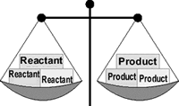A chemical equation must have the same number of atoms of each element on both sides of the arrow. When this condition is met, the equation is said to be **balanced**.

To count atoms, multiply the formula's coefficient by each symbol's subscript.

For example: 2Al2(SO4)3

* For Al - coefficient of 2, times subscript of 2 = 4 aluminum atoms
* For S - coefficient of 2, times subscript inside parenthesis of 1, times subscript outside parenthesis of 3 = 6 sulfur atoms
* For O - coefficient of 2, times subscript inside parenthesis of 4, times subscript outside parenthesis of 3 = 24 oxygen atoms

  The order in which the following steps are performed is important. While shortcuts are possible, (and you will learn about one), following these steps in order is the best way to be sure you are correct.

**Balance equations "by inspection" with these steps:**

1. Check for diatomic molecules.
2. Balance the metals (not Hydrogen).
3. Balance the nonmetals (not Oxygen).
4. Balance oxygen.
5. Balance hydrogen.
6. The equation should now be balanced, **but**recount all atoms to be sure.
7. Reduce coefficients (if needed). ALL coefficients must be reducable before you can reduce. An equation is not properly balanced if the coefficients are not written in their lowest whole-number ratio.

HINT: NEVER change subscripts to balance equations.

The **physical state** of each substance in a reaction may be shown in an equation by placing the

following symbols to the right of the formula:

* (*g*)   for gas
* (*l*)   for liquid
* (*s*)   for solid
* (*aq*)   for aqueous (water) solution

[**Stoichiometry**](http://en.wikipedia.org/wiki/Stoichiometry) is the quantitative study of chemical changes.

The most common type of stoichiometry calculation is a mass-mass problem. Generally, a mass-mass problem looks like this: "given this amount of reactant, how much product will form?"

**Steps in solving a mass-mass problem:**

1. Write a balanced equation for the reaction.
2. Write the given mass on a factor-label form.
3. Convert mass of reactant to moles of reactant.
4. Convert moles of reactant to moles of product.
5. Convert moles of product to grams of product.
6. Pick up the calculator and do the math.

**Mass-Mass Sample Problem:**

If iron pyrite, FeS2, is not removed from coal, oxygen from the air will combine with both the iron and the sulfur as coal burns. If a furnace burns an amount of coal containing 125 g of FeS2,

how much SO2 (an air pollutant) is produced?

1. Write a balanced equation showing the formation of iron (III) oxide and sulfur dioxide.

4 FeS2 + 11 O2 → 2 Fe2O3 + 8 SO2

2. Write the mass information given in the problem.

3. Convert grams of FeS2 to moles of FeS2.

4. Changes moles of FeS2 (reactant) to moles of SO2 (product).

This ratio comes from the coefficients in the balanced equation. Notice that the ratio was reduced from 8 : 4 to 2 : 1 when placed in the dimensional analysis form. While reducing is not

absolutely necessary (the ratio will cancel properly even if not reduced), a good chemistry student notices such things and will do it.

5. Convert moles of SO2 to grams of SO2 .

6. All units have been canceled except for grams of SO2 (product). The problem has been solved. Pick up the calculator and do the math.

[Stoichiometry](http://crescentok.com/staff/jaskew/isr/chemistry/a152.htm)

  The **limiting reactant** is the reactant that is completely consumed in the reaction.

* The limiting reactant is not present in sufficient quantity to react with all other reactants.
* The reaction **stops** when the limiting reactant is completely consumed.
* Any remaining reactants are considered **"excess reactants"**.
* The amount of product formed is determined by the "limiting reactant".

**Steps in solving a limiting reactant problem:**

1. Write a balanced equation for the reaction.
2. Convert both reactant quantities to moles.
3. Determine the moles of product that could be formed by each reactant.
4. The least amount in step #3 identifies the limiting reactant.
5. Use that number of moles of product to determine the mass produced.

**A limiting reactant problem example:** What mass of water can be produced by 4 grams of hydrogen gas reacting with 16 grams of oxygen gas?

The problem solution:

1. Write a balanced equation for the reaction.

2 H2 + O2 → 2 H2O

2. Convert both reactant quantities to moles.

Using the mole ratio from the equation, determine the moles of water that could be formed by each reactant.

4. Oxygen produces the least amount of water.

* 16 grams of oxygen cannot produce as much water as 4 grams of hydrogen. In other words, 16 grams of oxygen will be used up in the reaction before 4 grams of hydrogen.
* Oxygen is the "limiting" reactant.
* Use oxygen for the calculation of product amount.

5. Complete the problem by converting moles of H2O to mass of H2O.

The theoretical yield for this problem is 18 grams. If you performed this reaction in the lab, your actual yield might be less. Can you think of reasons why?

[Limiting Reactant Problems](http://crescentok.com/staff/jaskew/isr/chemistry/a154.htm)

**Percent Yield**

* The quantity of product that is calculated to form when all the limiting reactant is used up is called the **theoretical yield**.
* The amount of product actually obtained in a reaction is called the **actual yield**.
* The actual yield is almost always less than (and never greater than) the theoretical yield.

http://crescentok.com/staff/jaskew/isr/chemistry/yield.gif

**Sample problem:**

Given the reaction:

Fe2O3(*s*) + 3CO(*g*) → 2Fe(*s*) + 3CO2(*aq*)

A. If you start with 155 g of Fe2O3 as the limiting reactant, what is the theoretical yield of Fe?

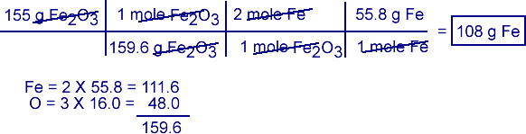

B. If the actual yield of Fe was 87.9 g, what was the percent yield?

http://crescentok.com/staff/jaskew/isr/chemistry/stoich12.gif

  EVALUATION

1. S8 + O2 → SO3
2. HgO → Hg + O
3. Zn + HCl → H2 + ZnCl2
4. Na + H2O → NaOH + H2
5. C10H16 + Cl → C + HCl
6. 5.Si2H3 + O2 → SiO2 + H2O
7. Fe + O → Fe2O3
8. FeS2 + O2 → Fe2O3 + SO2
9. Fe2O3 + H2 → Fe + H2O
10. K + Br →
11. C2H2 + O2 →
12. H2O2 → H2O + O2
13. C7H16 + O2 → CO2 + H2O
14. SiO2 + HF →
15. KClO3 → KCl + O2
16. KClO3 → KClO4 + KCl
17. P4O10 + H2O → H3PO4
18. Sb + O → Sb4O6
19. Fe2O3 + CO → Fe + CO2
20. PCl5 + H2O → HCl + H3PO4
21. H2S + Cl → S8 + HCl
22. Fe + H2O → Fe3O4 + H2
23. N + H → NH3
24. N2 + O2 → N2O
25. CO2 + H2O → C6H12O6 + O
26. SiCl4 + H2O → H4SiO4 + HCl
27. H3PO4 → H4P2O7 + H2O
28. Al(OH)3 + H2SO4 → Al2(SO4)3 + H2O
29. Fe2(SO4)3 + KOH → K2SO4 + Fe(OH)3
30. H2SO4 + HI → H2S + I + H2O
31. Al + FeO →
32. P4 + O2 → P2O5

K2O + H2O → KOH

1. Na2O2 + H2O → NaOH + O
2. C + H2O → CO + H
3. H3AsO4 → As2O5 + H2O
4. Al2(SO4)3 + Ca(OH)2 →
5. FeCl3 + NH4OH →
6. Ca3(PO4)2 + SiO2 → P4O10 + CaSiO3
7. N2O5 + H2O → HNO3
8. Al + HCl http://crescentok.com/staff/jaskew/isr/chemistry/arrow.jpg
9. H3BO3 → H4B6O11 + H2O
10. Mg + N →
11. NaOH + Cl → NaCl + NaClO + H2O
12. Li2O + H2O → LiOH
13. CaC2 + H2O → C2H2 + Ca(OH)2
14. Fe(OH)3 → Fe2O3 + H2O
15. Pb(NO3)2 → PbO + NO2 + O
16. Ca + AlCl3 → CaCl2 + Al
17. NH3 + NO → N + H2O
18. H3PO3 → H3PO4 + PH3
19. Fe2O3 + C → CO + Fe
20. FeS + O2 → Fe2O3 + SO2
21. NH3 + O → NO + H2O
22. Hg2CO3 → Hg + HgO + CO2
23. SiC + Cl → SiCl4 + C
24. Al4C3 + H2O → CH4 + Al(OH)3
25. Ag2S + KCN → KAg(CN)2 + K2S
26. Au2S3 + H → Au + H2S
27. ClO2 + H2O → HClO2 + HClO3
28. MnO2 + HCl → MnCl2 + H2O + Cl

1.From XNH3(g)+YO2-ZNO(g)+QH2O(g)

The value of Z is

(A) .4 (B) .7 (C).6 (D).5

2.One molecule of oxygen atoms

(A).has a molar mass of 32g (B).has 6.02x 1023

(C).can be represented as O2 (D) .has a formula mass of 16

(E) Contains Avogadro’s number of atom

3.The numerical coefficients in a balanced equation give

(A).the number of moles of reactants and products

(B).the molar mass of the reactants and products

(C).the number of moles of reactants only

(D).the number of molecules and atoms of products

(E).the mass ratio of the reactants

**WEEK 4 & 5**

**STATE,ILLUSTRATION AND VERIFICATION OF CHEMICAL LAWS**

**Law of Conservation of Mass**

In 1774, Joseph Priestley isolated the gas oxygen by heating mercuric oxide. Soon thereafter, Antoine Lavoisier claimed that oxygen is the key substance involved in combustion (burning). He also demonstrated that when combustion is carried out in a closed container, the mass of the final products of combustion exactly equals the mass of the starting reactants. This led to the statement of the Law of Conservation of Mass:

**Law of Conservation of Mass**

Mass is neither created nor destroyed in chemical reactions.

In an experiment, 63.5g of copper combines with 16g of oxygen to give 79.5g of cupric oxide (a black oxide of copper). This is in agreement with the law of conservation of mass.

Science today knows that matter can be converted into energy (and vice-versa). Hence, during all chemical and physical changes, the total mass+energy before the change is equal to the total mass+energy after the change. Still, as there is no detectable change in mass in an ordinary chemical reaction, the law of conservation of mass is still valid.

Silicon dioxide, made up of elements silicon and oxygen, contains 46.7% by mass of silicon. With what mass of oxygen will 10g of silicon combine?

100g of silicon dioxide contains : 46.7g of silicon,

or : (100 – 46.7) i.e. 53.3g of oxygen.

∴ 10g of silicon will contain 10100 × 53.3=5.33g of oxygen.

**Law of Definite Proportions / Constant Composition**

In the years following Lavoisier, the French chemist Joseph Proust formulated a second fundamental law of chemical science – the Law of Definite Proportions.

**Law of Definite Proportions (Law of Constant Composition)**

In a given compound, the constituent elements are always combined in the same proportions by mass, regardless of the origin or mode of preparation of the compound.

What this law means is that when elements react chemically, they combine in specific proportions, not in random proportions.

A sample of pure water, whatever the source, always contains 88.9% by mass of oxygen and 11.1% by mass of hydrogen.

The compound cupric oxide may be prepared by any one of the following methods –

• Heating copper in oxygen.

• Dissolving copper in nitric acid and igniting the cupric nitrate formed.

• Dissolving copper in nitric acid, precipitating cupric hydroxide, and strongly heating the cupric hydroxide.

– and in each case, the ratio copper:oxygen by mass is always constant.

2.16g of mercuric oxide gave on decomposition 0.16g of oxygen. In another experiment 16g of mercury was obtained by the decomposition of 17.28g of mercuric oxide. Show that these data conform to the law of definite proportions.

Experiment 1:

Mass of mercuric oxide = 2.16g

Mass of oxygen evolved from it = 0.16g

∴ Mass of silicon in the compound = 2.16 - 0.16 = 2.00

∴ silicon:oxygen ratio = 2.000.16 = 12.5 : 1

Experiment 2:

Mass of mercuric oxide = 17.28g

Mass of silicon in it = 16.00g ∴ Mass of oxygen in the compound = 17.28 - 16.00 = 1.28g

∴ silicon:oxygen ratio = 16.001.28 = 12.5 : 1

In both cases, the silicon to oxygen ratio is the same, thus conforming to the law of definite proportions.

**QUESTIONS**

(a) Two different sample, 1 and 2 of Zinc oxide were obtained from different sources. When heated in a stream of hydrogen they wre reduced to yield the results below.

|  |  |  |
| --- | --- | --- |
| Zinc Oxide | Mass of Oxide | Mass of Zinc left |
| Sample 1 | 20.0g | 16.22g |
| Sample 2 | 26.4g | 21.7g |

Show that the result above explains the law of constant composition.

(b) If 12.0g of carbon is heated in air, the mass of the product obtained could either be 44.0g or 28.0g depending on the amount of oxygen present. What law does this information support?

**WEEK 6**

**CHEMICAL BONDING**

**INTRODUCTION**

Though the periodic table has only 118 or so [elements](http://www.visionlearning.com/en/glossary/view/element/pop), there are obviously more substances in nature than 118 pure elements. This is because [atoms](http://www.visionlearning.com/en/glossary/view/atom/pop) can react with one another to form new substances called [compounds](http://www.visionlearning.com/en/glossary/view/compound/pop) . Formed when two or more atoms chemically [bond](http://www.visionlearning.com/en/glossary/view/bond/pop) together, the resulting compound is unique both chemically and physically from its [parent](http://www.visionlearning.com/en/glossary/view/parent/pop) atoms.

Let's look at an example.  The [element](http://www.visionlearning.com/en/glossary/view/element/pop) sodium is a silver-colored metal that reacts so violently with water that flames are produced when sodium gets wet.  The element chlorine is a greenish-colored [gas](http://www.visionlearning.com/en/glossary/view/gas/pop) that is so poisonous that it was used as a weapon in World War I.  When chemically bonded together, these two dangerous substances form the [compound](http://www.visionlearning.com/en/glossary/view/compound/pop) sodium chloride, a compound so safe that we eat it every day - common table salt!

[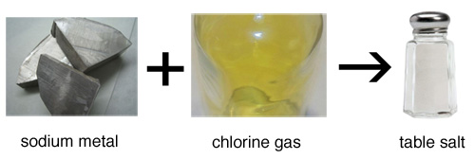](http://www.visionlearning.com/img/library/large_images/image_5161.jpg)

In 1916, the American chemist Gilbert [Newton](http://www.visionlearning.com/en/glossary/view/Isaac+Newton/pop) Lewis proposed that chemical [bonds](http://www.visionlearning.com/en/glossary/view/bond/pop) are formed between [atoms](http://www.visionlearning.com/en/glossary/view/atom/pop) because [electrons](http://www.visionlearning.com/en/glossary/view/electron/pop) from the atoms interact with each other. Lewis had observed that many [elements](http://www.visionlearning.com/en/glossary/view/element/pop) are most stable when they contain eight electrons in their [valence](http://www.visionlearning.com/en/glossary/view/valence/pop) shell. He suggested that atoms with fewer than eight [valence electrons](http://www.visionlearning.com/en/glossary/view/valence+electron/pop) bond together to share electrons and complete their [valence shells](http://www.visionlearning.com/en/glossary/view/valence+shell/pop).

While some of Lewis' predictions have since been proven incorrect (he suggested that [electrons](http://www.visionlearning.com/en/glossary/view/electron/pop) occupy cube-shaped orbitals), his [work](http://www.visionlearning.com/en/glossary/view/work/pop) established the basis of what is known today about chemical [bonding](http://www.visionlearning.com/en/glossary/view/bonding/pop).

**MAIN TYPES OF CHEMICAL COMBINATION**

1. Electrovalent/ionic combination
2. Covalent classified into:
3. Ordinary covalent
4. Coordinate or dative covalent.

**EXAMPLES OF ELECTROVALENT**

1. Formation of NaCl

|  |  |  |
| --- | --- | --- |
|  | Na atom | Cl atom |
| Before | 11  2,8,1 | 17  2, 8, 7 |
| After | 11  2,8 | 18  2,8,8 |

Equation: Na – e → Na+Cl + e →Cl

Na + Cl Na+ + Cl-

Diagram

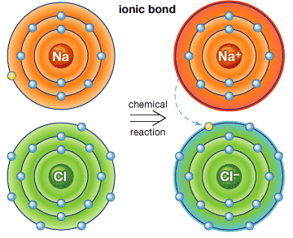

Na = 2, 8, 1 Cl = 2,8,7 Na+ = 2,8 Cl = 2,8,8

1. **FORMATION OF MgO**

|  |  |  |
| --- | --- | --- |
|  | Mg | O |
| Before | 12 = 2,8,2 | 8= 2,6 |
| After | 12 = 2,8 | 8 = 2,8 |

Equation: Mg – 2e → Mg 2+ O + 2e- → O2-

Mg + O → Mg2+O2-

**FORMATION OF MgCl2**

|  |  |  |
| --- | --- | --- |
|  | Mg | Cl |
| Before | 12 = 2,8,2 | 17 = 2,8,7 |
| After | 12 = 2,8 | 17 = 2,8,8 |

**Equation**

Mg – 2e → Mg2+Cl + 2e → 2Cl

Diagram

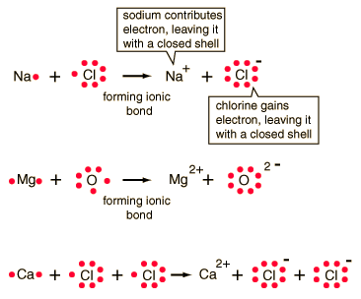

**PROPERTIES**

1. Electrostatic forces of attraction are strong
2. Consist of ions
3. In terms of structure, they exist as solids at room temperature, arranged in orderly manner to form crystals ie. =ve ion
4. surrounded be –ve ion and vice verse e.g.

NaCl crystals

=Cl- ion

=Na+ ion

They are hard. If force is applied, it gets scattered but does not change shape

1. High mpt and bpt because of strong bond between ions. E.g. NaCl melts at 8010 C and its bpt 14670C.
2. Soluble in polar solvents e.g. water, ethanol but insoluble in non-polar solvent e.g. benzene, CCl4

**HOW?**

When NaCl for example is placed in water, the

water surrounds individual ions (Na+Cl-) in the surface and exposes the inner layers of NaCl ions.

1. Good conductors or electrolytes of electricity.

**Reason:** the ions are free to move about when in a liquid state or in solution.

|  |  |  |  |
| --- | --- | --- | --- |
| Covalent Bonds Covalent chemical [bonds](http://hyperphysics.phy-astr.gsu.edu/hbase/chemical/bond.html#c1) involve the sharing of a pair of valence electrons by two atoms, in contrast to the transfer of electrons in [ionic](http://hyperphysics.phy-astr.gsu.edu/hbase/chemical/bond.html#c4) bonds. Such bonds lead to stable molecules if they share electrons in such a way as to create a noble gas configuration for each atom.  Hydrogen gas forms the simplest covalent bond in the diatomic[hydrogen molecule](http://hyperphysics.phy-astr.gsu.edu/hbase/molecule/hmol.html#c1). The halogens such as chlorine also exist as diatomic gases by forming covalent bonds. The nitrogen and oxygen which makes up the bulk of the atmosphere also exhibits covalent bonding in forming diatomic molecules.   |  |  | | --- | --- | | http://hyperphysics.phy-astr.gsu.edu/hbase/chemical/imgche/lewisbond2.gif | Covalent bonding can be visualized with the aid of [Lewis diagrams](http://hyperphysics.phy-astr.gsu.edu/hbase/chemical/lewis.html#c1). |  |  | | --- | |  | |
| |  | | --- | |  | |

**EXAMPLES OF COVALENT COMPOUNDS**

1. Formation of a hydrogen molecule H2
2. Formation of HCl
3. Formation of H2O

2H2O + O2 → 2H2O

1. C + 2H2 → CH4

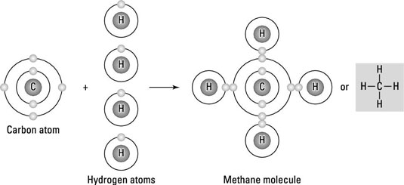

1. Formation with double bond – CO2

C + O2→ CO2 O = C = O

Covalent bonds i.e. where each atom contributes a pair of electrons

**PROPERTIES**

1. Consists of molecules
2. Electrostatic forces are not strong
3. Low m.pt and b.pt
4. Usually dissolve in non-polar solvent and insoluble in polar solvent
5. Poor conductor of electricity and heat

**Reason:** Molecules do not contain charged ions

1. They are often gases or volatile liquids e.g. iodine molecule.
2. [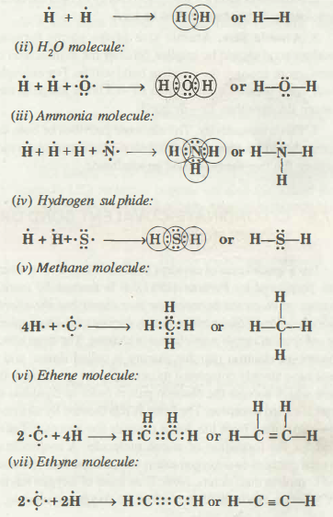](http://www.chemistry-assignment.com/wp-content/uploads/2013/01/141.png)

**HYDROGEN BOND**

Bond between hydrogen and any strongly electro negative elements e.g. N, O, and F. They are covalently bonded.

They form dipole i.e. coming together of a positive pole (H) and negative pole (N) or (F). The bond is weak.

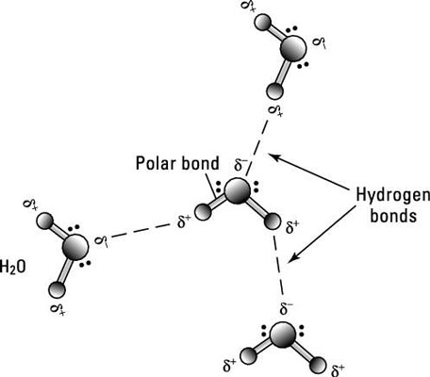

**Exercise:** HF, H2O, NH3

The hydrogen bond is responsible for:

1. B.pt of water (1000C) is high than that of H2S (-650C.). The oxygen in water has more affinity for e- than sulphur hence H2O has a stronger bond.
2. Easy logue faction e.g NH3
3. Solubility of some organic compounds in water e.g. ethanol, sugar.

**OTHER BINDING FORCES**

1. **Metallic Bond:**  holds metal atoms together in crystal lattices.



**Note:** the outer most e- in the metal form the electron cloud which determines how strong the metallic bond is going to be i.e. the larger the number of e- in the electron cloud the stronger the metallic bonding.

**Metallic bonding is responsible for metals:**

1. High m.pt e.g. iron is 15350C, Na = 980C,
2. because of few e-s in the outer most shell.
3. Malleability and ductility. Because layers of metallic atoms can slide over each other
4. High electrical and heat conductivity because close packing of particles
5. Light densities e.g. Iron = 7.8gcm-3

v.High boiling point

# Metallic Bond

[Home](http://www.chemistry-assignment.com) → Metallic Bond

Metals constitute about three-fourth of all the known elements. They have characteristic properties such as bright lustre, high electrical and thermal conductivity, malleability and ductility and high tensile strength. The attractive force which binds various metal atoms together is called metallic bond. The metallic bond is neither a covalent bond nor an ionic bond because neither of these bonds are able to explain the known properties of metals. For example, neither ionic nor covalent compounds conduct electricity in the solid stale but metals are very good conductors of electricity. In order to explain bonding in metals different theories have been put forward. We shall be studying here electron gas model or electron sea model for metallic bonding.

**ELECTRON GAS MODEL OR ELECTRON SEA MODEL**

This is the simplest model that explains the properties of metals. This model was proposed by Lorentz. The main features of this modal are:

1. A metal atom is supposed to consist of two parts, valence electrons and the remaining part (the nucleus and inner shells) which is called kernel.

2. The metallic crystal consists of crystal packed metal atoms in three dimensions. The kernels of metal atoms occupy fixed positions called Lattice sites while space between the kernels is occupied by valence electrons. The arrangement of kernels and valence electrons is shown in Fig. 7.16.

[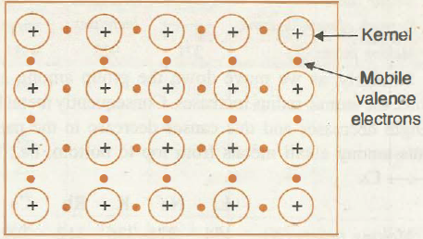](http://www.chemistry-assignment.com/wp-content/uploads/2013/01/164.png)

**Fig. 7.16. Arrangement of metallic kernels.**

3. Due to smaller ionisation energy, the valence electrons of metal atoms are not held by the nucleus very firmly. Therefore, they can leave the field of influence of one kernel and enter the field of influence of the other. This movement can take place through the vacant valence orbitals. Thus, the valence electrons are not localised but are mobile or delocalised. As the movement of electrons in metallic crystal is just like gas molecules, hence, the model is called electron gas model.

4. The simultaneous force of attraction between the mobile electrons and the positive kernels is responsible for holding the metal atoms together and is known as metallic bond.

The metallic bond is non-directional and is weaker than the covalent bond.

**STRENGHT OF METALLI C BONO**

Strength of metallic bond depends on the magnitude of attractive force between positive kernels and mobile valence electrons.

The average attractive force and metal bond strength increases with the decrease in atomic radius and increase in number of valence electrons. It must be noted carefully that both these factors at the same time decrease the metal character because of the tendency to form metallic crystal decreases. For example when we move along the period from left to right metallic character decreases. Among the elements of 3rd period metal character decreases from left to right. The metallic elements are only Na, Mg, AI, but strength of metallic bond increases from Na -7 AI. It is reflected from their melting points.

[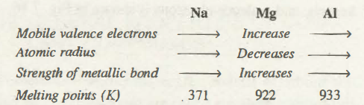](http://www.chemistry-assignment.com/wp-content/uploads/2013/01/165.png)

Similarly, as we move down the group among alkali metals, the atomic radius increases. Consequently metal bond strength decreases and this causes decrease in the melting points among alkali metals from top to bottom, i.e., from LiàCs

Li        Na        K        Rb       Cs

Melting points (K)     454     371      336      312     302

**FACTORS THAT FAVOUR THE METALLIC BONDING**

Metallic bonding is generally favoured by the following factors:

1. The atomic size of the element should be large.

2. Ionisation energy of the element should be low

3. Electron affinity of the element should be low

4. The Umber of valence electrons should be small (usually 1-2)

5. The number of vacant orbitals in the valence shell should be large.

**EXPLANATION ON OF PHYSICAL PROPERTIES OF METALS**

**1. Metallic Lustre.** When light falls on the surface of the metal, the free electrons absorb the photons of light and are set into vibrations. These vibrating electrons immediately emit energy and become a source of light. Thus, incident light appears to be reflected from the surface of the metal. Consequently the metallic surface acquires a shining appearance which is referred to as metallic lustre.

**2. Electrical Conductivity.** Whenever a difference is applied across the metallic strip, the free mobile electrons in the metal start moving towm-ds positive terminal At the same time the electrons from the negative terminal enter into the metallic crystal. Thus, metallic crystal maintains flow of electron from negative to positive terminal.

At high temperature, the metallic kernels start due to increase of the kinetic energy. This restricts the free movement of the electrons. Consequently, the resistance of  metals increases with the increase in the temperature.

[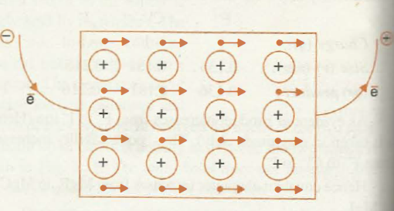](http://www.chemistry-assignment.com/wp-content/uploads/2013/01/166.png)

**Fig. 7 .17. Electrical conductivity of metals.**

**3. Thermal Conductivity.** The conduction of through the metals can also be explained on the basic electron gas mode\. On heating a part of the metal, the kinetic energy of the electrons in that region increases. These energetic electrons move rapidly to the cooler parts and transfer their kinetic energy by means of collisions with other electrons . In this way, the heat travels from hotter to cooler parts of the metals.

**4. Malleability and Ductility.** Malleability is the property of metals by virtue of which they can be beaten into sheets whereas ductility is the property by virtue of which they   can. be drawn into wires. These properties are exhibited by metals on account of the  of non-directional nature of metallic bond. Whenever any stress is applied on metal, the position of metallic kernels is altered without destroying the crystal The crystal lattice gets deformed by slippage of the layers of kernels moving past to another as shown in fig 7.18. whenone layer of kernels moves past another, the positive on metal ions are shielded from each other by the electrons.

The electron sea model could explain the properties metals qualitatively. However, the properties of metals be explained more quantitatively by molecular orbital which is beyond the scope of this book.

[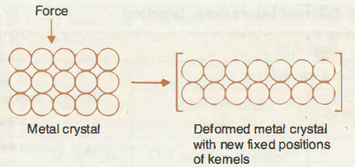](http://www.chemistry-assignment.com/wp-content/uploads/2013/01/167.png)

**Fig. 7.18. Malleability and ductility of metals.**

The general properties associated with three primary interatomic bonds are being summarized in tabular form as follows.

**General Characteristics of Substances with different Interatomic Bonding**

[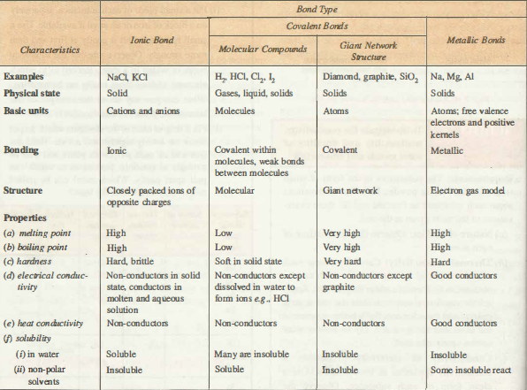](http://www.chemistry-assignment.com/wp-content/uploads/2013/01/168.png)

**Van der waal forces**

* Very weak
* Very important in the liquifaction of gases and in the formation of molecular lattices e.g. in iodine and Naphthalene crystals.

**COORDINATE COVALENT COMBINATION**

Electrons to be shared are donated by only one of the participating atoms. Such pair of e- s are called Ione pair. This combination always leads to the formation of complex ions.

# Co-ordinate-Covalent Bond or Dative Bond

[Home](http://www.chemistry-assignment.com) → Co-ordinate-Covalent Bond or Dative Bond

It is a special case of covalent bond the formation of which was postulated by Perkins (1921). It is formed by mutual sharing of electrons between the two atoms but the shared pair of electrons is contributed only by one of the two atoms, the other atom simply participates in sharing. The atom which donates an electron pair for sharing is called donor and it must have already completed its octet. On the other hand, the atom which accepts the electron pair in order to complete its octet is called acceptor. The bond is represented by an arrow      pointing from the donor towards the acceptor. Let us consider the formation of ozone molecule. A molecule of, -oxygen contains two oxygen atoms which share four electrons and complete their octets. Now, if an atom of oxygen having six valence electrons comes close to oxygen molecule, it  shares a lone pair of electrons with one of the oxygen of the molecule. It can be represented as follows:

[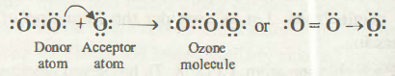](http://www.chemistry-assignment.com/wp-content/uploads/2013/01/143.png)

It is important to note that co-ordinate bond one formed, cannot be distinguished from covalent bond.

Some more examples of molecules/polyatomic ions having co-ordinate bond are as follows:

(i) SO2 molecule

[http://www.chemistry-assignment.com/wp-content/uploads/2013/01/147.png](http://www.chemistry-assignment.com/wp-content/uploads/2013/01/147.png)

(ii) Ammonium ion

[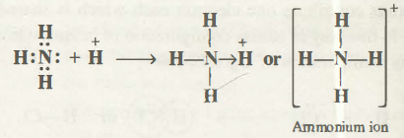](http://www.chemistry-assignment.com/wp-content/uploads/2013/01/148.png)

(iii) Hydronium ion

[](http://www.chemistry-assignment.com/wp-content/uploads/2013/01/149.png)

(iv) Carbon (II) oxide. In this molecule carbon and oxygen atoms contribute two electrons forming pure covalent bonds. At the same time oxygen also act as donor atom to form co-ordinate covalent bond.

[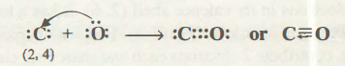](http://www.chemistry-assignment.com/wp-content/uploads/2013/01/150.png)

**Exercise**

1. Formation of ammonium ion

Reaction between NH3 and HCl acid. The H+ of

the acid reacts with NH3and NH4+ is formed.

2 .Formation of oxonium ion or Hydroxonium ion

**QUESTIONS**

What are the types of bonding that exist in the following compounds.

1.HCl

2. NH4Cl

With diagram and equations only , illustrate the

formation of:

1. Oxygen molecule
2. Ethane molecule
3. Ammonia molecule
4. Nitrogen molecule
5. Al2O3

Which of the compounds in 2 above is/are Triple covalently bonded?

1. Which of the following species the constituent atoms are held by non-directional bonds?

(a) NH3           (b) CsCl

(c) NF3           (d) BeF2.

2. X and Y atoms have 2 and 6 valance electrons in their outermost shells respectively, the compound which X and Y are likely to form is:

(a) XY 2          (b) XY

(c) YX2           (d) YX3.

3. Which of the following substance is a polar covalent molecule?

(a) Hydrogen sulphide            (b) Nitrogen

(c) Potassium chloride                       (d) Oxygen.

4. Which of the following statement is/are correct?

I. Energy is absorbed when a chemical bond is formed

II. Energy is released when a chemical bond is formed

III. SF 6 is a super octet molecule

(a) I and III      (b) III and II

(c) II only          (d) III only

5.In electrovalency,valence electrons are transferred and the atomic number is

(A) .also reduced (B).stabilized (C) .unaffected (D).destabilized

6.Arrangement of ions in a regular pattern in a solid crystal is called

(A).configuration(B).atomic structure(C).lattice(D).Buffer

7.The bond type in a diatomic nitrogen gas is

(A).double covalent bond (B).triple covalent bond

(C).single covalent bond (D).double covalent bond

8.The bond type between copper( ii )ion and water molecules is

(A).electrovalent bond (B).covalent bond (C).Dative covalent bond

(D).Hydrogen bond

9.The bond between two iodine molecules is

(A).co-ordinate bond (B) electrovalent bond (C).ionic bond

(D)Van der waal’s forces

10.Bonds between a highly electronegative atom and a hydrogen from another molecule is called

(A).hydrogen bond (B).covalent bond (C).intermolecular forces (D).Ligand

**WEEK 7**

**KINETIC THEORY OF GASES**

The gas; laws, which explain the physical behavior of gases can be explained by the kinetic theory of gases. This states that:

1. The gas molecules move randomly in straight lines, colliding with one another and with the wall of the container. Example: if a bottle of perfume is opened, the smell is quickly detected everywhere.
2. The collision of gas molecules are perfectly elastic i.e. when the molecules collide with the wall of the container, they re-bounce like elastic balls without any loss of energy.
3. The actual volume occupied by the gas molecules themselves is negligible i.e. the gas molecules are so small when compared with the volume of the container or distances between them.
4. The cohesive forces between the gas molecules are negligible
5. The temperature of the gas is a measure of the average kinetic energy of the gas particles

**NOTE:** the theory describes the behavior of an ideal gas, but not everything is true about real gas

**PRESSURE EXERTED BY GASES**

* Gas particles collide with each other and with the walls of the containers.
* Each time it happens, the gas exerts a very small force on the walls.
* This force per unit area is called gas pressure. It is constant.
* The gas pressure is measured in;

Atmosphere (atm)

Millimetre mercury (mmHg)

Pascal (Nm -2)

Relationship between the units

1 atm = 760mmHg = 101325 Nm-2

**SUMMARY OF KINETIC THEORY OF MATTER**

Particles of matter are continually moving in a random motion so posses kinetic energy.

**Using the Kinetic Theory to define the physical states of matter:**

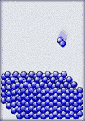[**Solid**](http://en.wikipedia.org/wiki/Solid) **- a substance whose particles have a low kinetic energy.** The particles of a solid are held close together by intermolecular forces of attraction. Because the particles are so close together, they appear to vibrate around a fixed point.

When the temperature of a solid is raised, the velocity of the particles increases. The collisions between the particles occur with greater force, causing the particles to more farther apart. The ordered arrangement of the solid breaks down and a change in physical state occurs.

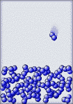[**Liquid**](http://en.wikipedia.org/wiki/Liquid) **- a substance whose particles have enough kinetic energy to stretch the intermolecular forces of attraction.** Collisions between the particles a strong enough to force the particles apart. The particles appear to have a moving vibration because they are still under the influence of the intermolecular forces of attraction.

As the temperature of a liquid is raised, the velocity of the particles increases. The collisions eventually become so great that the particles break all intermolecular forces, begin moving independently between collisions, and a change in physical state occurs.

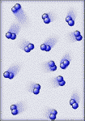[**Gas**](http://en.wikipedia.org/wiki/Gas) **- a substance whose particles have enough kinetic energy to break all intermolecular forces of attraction.** The particles of a gas move independently of each other. The particles move at random because they have overcome the intermolecular forces of attraction.

When a gas is raised to extreme temperatures, over 5000 oC, they have so much kinetic energy that their collisions will break electrons out of the atoms, and a change in physical state occurs.

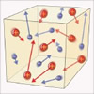[**Plasma**](http://en.wikipedia.org/wiki/Plasma_%28physics%29) **- a charged gas.** The particle collisions are violent enough to break electrons out of the atoms, producing particles with charges (electrons and positive ions).

Because of its extreme temperature, plasma is not common on Earth. Wet-lab chemistry is not concerned with plasma and its characteristics.

**Physical state at room temperature (25 oC) and standard atmospheric pressure:**

Under these conditions, the physical state of a substance is determined mainly by its chemical bond characteristics.

* Ionic compounds have strong electric charges holding the ions together as solids.
* Nonpolar molecular compounds of low molecular mass tend to be gases.

* + Greater molecular mass and greater polarity both tend to make substances more dense, producing either liquid or solid.

**Intermolecular forces of attraction:**

Within an atom, these forces are called **weak forces**, because they are much weaker than chemical bonds between atoms. Weak forces involve the attraction of the electrons of one atom for the protons of another atom.

When these forces interact between molecules, they are known as **van der Waals forces**.

**PHENOMENA SUPPORTING KINETIC THEORY**

* Nobody has seen the tiny particles that make up matter but scientist carried out

some work and ascertain that the particles are in constant motion

* The motion can be proved as follows:

1. **Brownian movement**

* By **Brown (a botanist in 1827**)
* He dropped a pollen grain in a drop of water and examined it under
* **Observation:** There was irregular movement of the grain (zigzag)
* **Conclusion:** Movement was caused by the bombardment of the

pollen grains by the water molecules

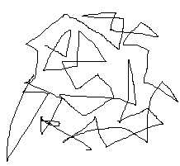

**Brownian movement**

1. **Diffusion**

Movement of solute particles through a medium from a medium of higher concentration to a region of lower concentration.

**Diffusion in Gases**

* Fastest (in seconds)
* Particles have more kinetic energy
* Rate of diffusion is affected by the densities of the gases.

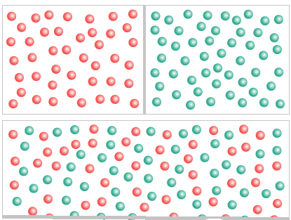

**NOTE**

1. NH3 gas diffuses faster than HCl because it is lighter than HCl.
2. The evidence of the above statement is that NH3 travels at one third of the tube (distance A) faster than HCl (distance B) i.e. A > B.
3. The molecular masses of the gases are used to determine the lighter gas i.e. the lower the molecular mass the faster the rate of diffusion. But where the molecular masses are equal, the 2 gasses diffuse at the same rate.

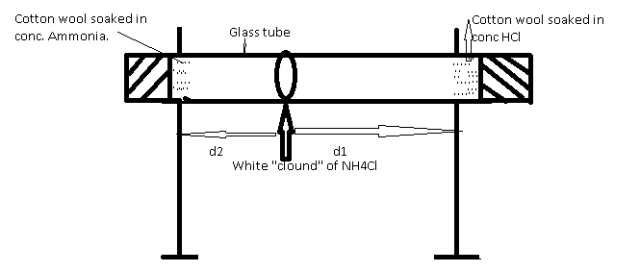

**NOTE:d1**and **d2 stands for distance**

**Diffusion of Liquids**

* slower than gasses (in minutes/hours)
* particles have less K.E

Jelly

CuSO4 CRYSTALS

....

.

**Rubber bung**

**Note**

1. the fine jets acts as the boundary in the beginning.
2. The blue CuSO4 solution spreads upwards, against gravity. Therefore, it liquids overcome the force of gravity.

**Diffusion in Solids.**

* Slowest ( in years )
* Particles have least K.E

1. **Osmosis**

* Special case of diffusion which involves the movement of water molecules
* Osmosis is the movement of water molecules, through a semi permeable membrane, from the region where they are in higher concentration to the region where they are in lower concentration.

**Example:** place some dried bean seed in a beaker of water and leave for some time.

**Observation:** The bean seed swell up

**Result:** water molecules have moved through the skin of the seed (semi-permeable) into the seeds by osmosis.

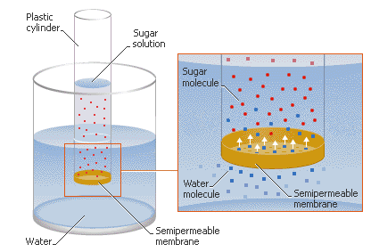

**EVALUATION**

1.The escape of molecules with more than average kinetic energy of the molecule

(A).melting (B).freezing (C).evaporation (D).efflorescence

2.The phenomenon whereby the atmospheric pressure equals the saturated vapour pressure is called

(A).freezing (B).latent heat (C).boiling (D).normal pressure

3 .Using the kinetic theory of matter, describe the nature of the following states of matter.

4.State the kinetic theory of matter and outline 3 natural phenomena which support it.

**WEEK 8**

**GAS LAWS**

Behaviour of gases is expected to differ from that of solids and liquids. This was investigated by many early scientists e.g. Boyle, Charles, Graham and Dalton, Avogadro’s. They studied the physical behaviour of gases. Gay-Lussac: he studied the chemical behaviour.

**Boyle’s Law**

* By **Robert Boyle in 1662**
* States that the volume of a given mass of a gas is inversely proportional to its pressure, provided temperature remains constant.
* Law is about the relationship between volume (V) and pressure (P)

As volume of a gas increases, the pressure decreases and vice versa

**Mathematical expression**

V α 1/p

V α k/p

K = PV

V = volume

P = pressure

K = constant

For initial and final pressure and volume, we have

P1V1 = P2V2

According to the kinetic theory,the gas pressure is caused by molecular collisions with the walls of the container.Therefore, the larger the number of molecules per unit volume,the larger the number of collisions and the higher the pressure.Reducing the volume of a gas container will increase the collisions on the walls of the container per unit time and consequently the pressure of the gas will incr

**Using kinetic theory to explain Boyle’s Law**

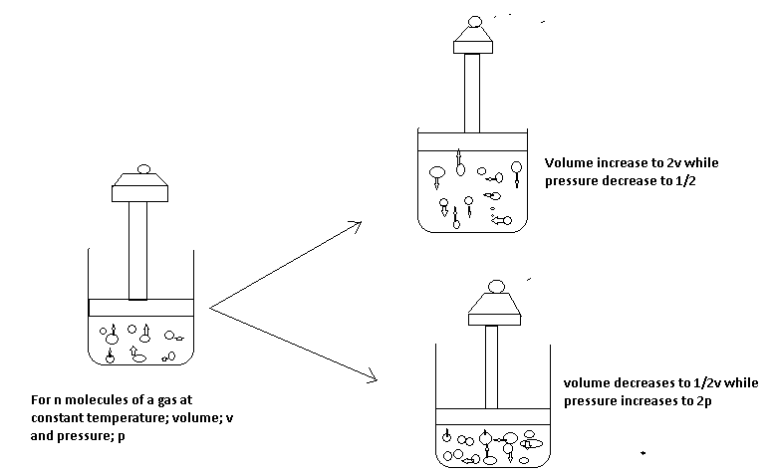

**NOTE:**

**In stage 2:**

* **The piston is kept stationary by placing a heavy weight on it.**
* **The space occupied by the molecules is constant i.e. volume is constant.**
* **The gas exerts constant pressure.**

**In stage II:**

* **Weight of piston is replaced with a lighter one, so the piston moves up.**
* **The space occupied by the gas is doubled (increased volume).**
* **The pressure exerted by the gas is halved (pressure increases).**

**In stage III:**

* Weight of the piston is now replaced with a heavier one, so the piston moved down.
* The space occupied by the gas is halved (volume decreases)
* The pressure exerted by the gas is doubled (pressure increases)

Therefore, at constant temperature; as the volume of a gas decreases, the pressure the gas exerts increases. Example, Ababio page 31, Fig. 5.15

V

0 **1/P**

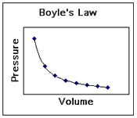

**Calculation Involving Boyle’s Law**

**The volume of a gas means nothing unless the   
conditions under which it was measured are known.**

Tips for working with gas laws:

* **All gas calculations must use Kelvin temperatures.**
* The conditions **0 oC** and **1 atm** are referred to as **standard temperature and pressure** - **STP.**
* The volume occupied by one mole of a gas at STP, 22.4 liters, is referred to as **molar volume**.
* Read the problem to see what conditions change.
* Decide which gas law to use and write its equation.
* Reread the problem to see what question is asked.
* If needed, manipulate the gas law equation.
* Plug numbers and units into the equation.
* Pickup your calculator and punch buttons.
* Write the answer to the problem, *don't forget significant figures*, and circle it.

  Example 1

A sample of gas occupied 390cm3 ata pressure of 760mmHg.What volume will the gas occupy at 780mmHg, if the temperature remains constant?

Solution

P1V1=P2V2 (T constant)

P1=760mmHg

V1=390cm3

P2=789mmHg

V2=?

P1V1=P2V2 (Boyle’s law)

V2=P1V1/P2

=760mmHg x 390cm3/780mmHg

V2=380 cm3

1. 375cm3 of gas has a pressure of 770mmHg, Find its volume if the pressure is reduced to 750mmHg

**Ans = 385cm3**

**ABSOLUTE TEMPERATURE**

The temperature at which the volume of a gas would be theoretically reduced to O. This temperature is 0C or 273K.

**Note:** practically, it is not possible as all gases liquefy above this temperature but it is significant because it is the lowest possible temperature that can be reached.

**Temperature Conversion**

00C =273K, -2730C =0K (no degree sign)

C =Celsius or centigrade

K = Kelvin

To convert:

Celsius to Kelvin =K=0C + 273

Kelvin to Celsius = 0C = K-273

1000C 373K

00C 273K

-273OC 0K

CELSIUS SCALE KELVIN SCALE

**CHARLE’S LAW**

The volume of a given mass of a gas is directly proportional to its absolute temperature provided that pressure remains constant.

**MATHEMATICAL EXPRESSION**

V α T

V α KT

K= V

T

V = Volume, T = Temperature (in Kelvin), K= constant

For more than one gas, we have

V1 =V2

T1 T2

V2=  V1 T2

T1

The volume of a gas is zero at a temperature of -2730C which is zero Kelvin.

Charle’s laws explains that the behavior of gases at differenttemperature changes when the pressure is constant.Gases expand when heated.The rate of expansion or contraction is summaried as follows.At constant pressure,a gas increases by 1/273 of its volume for each Celsius degree rise in temperature and this is true for all gases.For every one degrr centrigrade rise or fall in temperature.

The Kelvin temperature scale has -273oC as its starting point and it is called the absolute temperature scale.

Hence,O0C=273K

-273=0

The Kelvin temperature scale has -273oC as its starting point and it is called the absolute temperature

[Charles' Law Problems](http://crescentok.com/staff/jaskew/isr/chemistry/a172.htm)

Example1

Whatvolume would be occupied by a given sample of gas at 450C if it occupies 500cm3 at O0c assuming the pressure is constant?

Solution

Acertain mass of gas occupies300cm3 at 350C .At what temperature willit have its volume reduced by half,assuming the pressure remains constant.

Solution

V1/T1=V2/T2

V1=300cm3

T1=350C=(273+35)K=308K

V2=150cm3

T2=?

300cm3/308K=150cm3/T2

T2=308K X 150cm3/300cm3

154K =(-1190C)

**USING KINETIC THEORY TO EXPLAIN CHARLE’S LAW. EXAMPLE.**

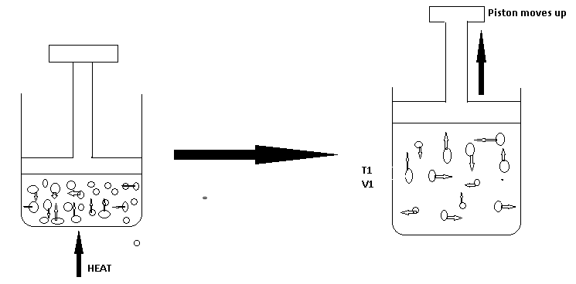

**NOTE:**

In stage:

The gas is heated, molecules acquire more kinetic energy, move faster and collide more often with the walls of the vessel, and hence, pressure is exerted.

In stage II:

The temperature is increased through heating **(T1 –T2).**

The pressure is still constant because the piston has been moved up but the volume occupied by the gas has increased.

**Conclusion**: As temperature increases, the volume increases and vice versa.

**Graphical illustration of Charles law.**

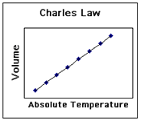

Ababio page 81, fig 5.16 and page 83

Vol (dm3) Vol

-273 O TempoC K

Calculations involving Charles law

1. At 170C, a sample of hydrogen gas occupies 125cm3. What will the volume be at 1000C, if the pressure remains constant? Ans. = 161cm3
2. To what temperature in Celsius must a gas be raised from 00C in order to double its volume? **Ans. = 2730C**
3. 20cm3 of a gas at 550C exerts 160mm Hg pressure. At the same pressure, calculate the volume of the temperature is doubled? **Ans. = 23.35cm3**

**GENERAL GAS EQUATION**

**Boyle’s and Charles’s laws** show that there is a relationship between the temperature, press and volume. The relationship is expressed by what is called **general gas equation** I.e.

Boyle’s law – V α 1/P

Charles Law - V α T **i**

Multiply (i) x (ii)

V α 1 X Vα T

V α (1/P X T)

V α T/P

V= KT/P

PV= KT

K= PV/T

Formorethan one gas,

P1 V1 = P2 V2V2= P1 V1 T 2

T1 T2  P2 T 1

where P1= initial pressure

V1=initial volume

T1= Initial Kelvin temperature

P2=New pressure

V2=New volume

T2=New Kelvin temperature

**STANDARD TEMPERATURE AND PRESSURE (S.T.P)**

**It is the generally** accepted standard temperature (00C or 273K) and pressure (760mmHg or 1.01 x 105Nm-2)

**NOTE: if two chemists, one** in a temperate country e.g. England and the other in tropical country e.g. Nigeria, should carry out investigations on the same gases. Their gas volumes would differ because of different in temperatures of the two countries. So, scientists decided to have standard temperature and pressure for calculations and experimentation.

**CALCULATIONS**

1. At s.t.p, a certain mass of gas occupies a volume of 790cm3. Find the temperature at which the gas occupies 1000cm3. Ans. = 330.1K
2. A given mass of a gas occupies 850cm3 at 320K and 0.92 x 105Nm-2 pressures. Calculate the volume of the gas at s.t.p Ans. = 660.5cm3
3. A sample of N2 occupies a volume of 1dm3 at 500k and 1.01 x 105 Nm-2. What will its volume be at 2.02 x 105Nm-2 and 400K?
4. To what temperature must a given mass of N2 at 00C be heated so that both its volume and pressure will be doubled?
5. 130cm3 of gas at 20oC exerts a pressure of 750mmHg. Calculate its pressure if its volume is increased to 150cm3 at 350C.
6. Calculate the volume of hydrogen produced at s.t.p and r.t.p when 25g of zinc are added to excess dilute Hydrochloric acid at 31oCand 778mmHg pressure (H= 1, Zn= 65, Cl= 35.5, GMV= 22.4dm3, 24 dm3 )
7. The combustion of butane in oxygen (air) is represented in the equation below: 2C4H10 + 1302 10H20 + 8CO2

**IDEAL GAS EQUATION**

In all experimental works, measurements or calculation involving gases, four quantities are important-**volume, pressure, temperature**, **and number of moles.** The first three have been used in general gas equation. But the combination of four of them gives **ideal gas equation** as:

**PV = nrt**

Where

P = Pressure (in atm)

V = Volume (in dm3)

n = No. of moles

R = Gas constant (0.082 atm dm3 k-1 mol-1)

T = Temp (in K)

**Gas density** can also be calculated using the ideal-gas equation.

Density is equal to mass divided by volume, d = m/v.

The ideal-gas equation can be arranged to give density in g/L:

http://crescentok.com/staff/jaskew/isr/chemistry/ideal2.gif

This equations shows the density of a gas depends on its pressure, molar mass, and temperature. The higher the molar mass and pressure, the greater the gas density; the higher the temperature, the less dense the gas.

Even though gases form homogeneous mixtures regardless of their identities, a less dense gas will lie above a more dense one if they are not physically mixed. The differences between the densities of hot and cold gases is responsible for CO2 being able to keep oxygen from reaching combustible materials (thus acting as a fire extinguisher) and for many weather phenomena, such as the formation of large thunderhead clouds during thunderstorms.

1. Under a pressure of 3000, Nm-2 a gas has a volume of 250cm3. What will its volume be if the pressure is changed to 100mmHgat the same

Temperature?

Solution to NO.3

Note: The pressure is not in the same unit. So conversion must be done first. 101325 Nm-2 = 760mmHg

3000Nm-2 =760 x 3000= 22.gmmHg

101325

P1 =22.5mmHg

Using P1 V1 = P2 V2

T1  T2

P2 = 100mmHg, V1 = 250cm3, V2 =?

**Ans= 56.25cm3**

**Dalton's Law of Partial Pressures**, established by [John Dalton,](http://en.wikipedia.org/wiki/John_Dalton) states that if there is a mixture of gases that do not react chemically together, then the total pressure exerted by the mixture is the sum of the partial pressures of the individual gases that make up the mixture i.e.

**PTotal =PA + PB + PC +…**

Where

**PTotal = Total pressure of the mixture**

**PA = Partial pressure of gas A**

**PB = Partial pressure of gas B**

**PC = Partial pressure of gas C**

Note:

1. Gases A, B and C make up the mixture.
2. If a gas is collected by water, it is likely to be saturated with water vapor and the total pressure becomes: Ptotal= Pgas + Pwatervapour

The pressure of the dry gas will now be:

**PGAS = PTOTAL -PWATER**

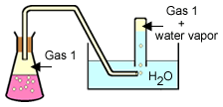Dalton's Law is helpful when collecting a gas "over water". This diagram shows the collection of a gas by water displacement.

A collecting tube is filled with water and inverted in an open pan of water. Gas is then allowed to rise into the tube, displacing the water. By raising or lowering the collecting tube until the water levels inside and outside the tube are the same, the pressure inside the tube is exactly that of the atmospheric pressure.

A gas collected "over water" is a mixture of the gas and water vapor. Dalton's law of partial pressures describes this situation as:

Ptotal = Pgas + PH2O

Charts [like this one](http://crescentok.com/staff/jaskew/isr/chemistry/dalton3.gif) are readily available that give water vapor pressure at any common temperature.

**EXERCISES**

1. A certain mass of hydrogen gas collected over water of 6o C and 765mmHg pressure has a volume of 35cm3. Calculate the volume when it is dry at s.t.p**. (s.v.p. of water at 6oC=7mmHg).**

**Solution**

To get the real pressure of H2 gas i.e. when it is dry:

**PDRY GAS =PTOTAL –PWATER VAPOUR =765 -7 =758mmHg**

Apply general gas equation to obtain the volume required in the question. **Ans= 34.2cm3**

2 .272cm3 of CO2 were collected over water at 15oC and 782mmHg pressure. Calculate the Volume of the dry gas at s. t. p. (s.v.p of water at 15 0C= 12mmHg)

3 .A given amount of gas was collected over water at 302K where the water vapour pressure of was 4.0 KNm-2. Calculate the pressure of the dry gas if the atmospheric pressure at the same temperature was 101.3 KNm-2

4 .200cm-2 of Nitrogen gas at a pressure of 500mmHg and 100cm3 of CO2 at a pressure of 50mmHg were introduced into a 150cm3 vessels. What is the total pressure in the vessel?

**Solution for No. 4**

For N2

V1 =200 cm3, P1 =500 mmHg

V2=150 cm3, P2 =? mmHg

P2= P1V1  = 666.67mmHg –**Boyles Law**

V2

For CO2

V1 =10 cm3, P1=50 mmHg, V2=150 cm3, P2 mmHg=?

P2-33.33mmHg.

Total pressure =666.67 +33.33 =700mmHg

1. A gas X was put in a 10dm3 vessel at 400K and 1.015 x 105 Nm-2. . Another gas Y at 400K and 3.035 x 105 Nm-2 is put in a 5dm3 vessels. What will be the total pressure if:
2. X and Y are put in a 5dm3 vessel at 400K?
3. X and Y are put in a 15dm3 vessel at 400K?
4. X and Y are put in a 10dm3 vessel at 400K?
5. X and Y are put in a 20dm3 vessel at 400K?

**SOLUTION**

For X

1. P1= 1.015 x 105 Nm-2, V1 = 10dm3, V2 = 5dm3, P2=?

P2 = P1V1 =2.03 X 105 Nm-2. NOTE: Temp is constant

V2

For Y

It already in 5 dm3 and it is 3.035 x 105 Nm-2

P total = Px + Py

=2.03 x 105 + 3.035 105

=5.065 x 105 Nm-2

**EVALUATION**

**EXERCISES**

1.A certain amount of gas occupies 5.0dm3 at 2 atm and 10 0 C. Calculate the number of moles present (R=0.082atm dm 3 K- 1mol- 1).

1. 2.0 moles of an Ideal Gas are at a temperature of -130C and a pressure of 2

Atm. What volume in dm3 will the gas occupy at a temperature?

**(R=0.082 atm dm3  K- 1  mol-1)**

3.A given mass of nitrogen is 0.12dm3 at 60C and 1.01 X 105 Nm-2. Find its pressure at the same temperature, if its volume is changed to 0.24dm3.

4.A certain mass of gas occupies 600cm3 and exerted 1.325 x 105 Nm-2 pressures. At what pressure would the volume of the gas be halved?

**Ans = 2.65** x **105 Nm-2**

5.Convert the following Kelvin temperature to Celsius temperature

A. 405K B. 298K

6.Convert the following Celsius temperature to Kelvin temperature

A. 00C B. -1320C

**WEEK 9**

**GAY LUSSAC’S LAW: It** states that when gasses react, they do so in volumes and these volumes are in simple ratio to one another and to volume of the product if gaseous provided the temperature and pressure remain constant.

Gay Lussac observed as follows:

**H2 + O2 2H2O**

**Volume 2 1 2**

**Ratio 2 : 1 : 2**

He noticed that the combining volumes as well as the volumes of the products were related by simple ratios of whole number, provided they are gases.

**EXERCISE**

1. 2O cm3 of CO are sparked with 20 cm3 of Oxygen. If all the volumes of gases are measured at s.t.p, calculate the volume of the residual gases after sparking.

**2CO (g) + O2(g) 2CO2(g)**

**SOLUTION**

**2CO2 (g) + O2 (g)** **2CO2 (g)**

Combining volume: · 2 : 1 : 2

Vol. before sparking: 20cm3 20cm3 -

Vol. during sparking: 20cm3 10cm3 20cm3

Vol. after sparking: - 10cm3 20cm3

Residual gases = Unreacted gas + Product formed

10 + 20 = 30cm3

2. 100cm3 of Nitrogen gases mixed together with 150 cm3 of Hydrogen. The mixtures were

made to react at low temperature at which the product cannot dissociate.

I. which of the two gases was in excess and by what volume?

ii. What was the volume of NH3 produced?

Equation for the reaction; N2 + 3H2 2NH3

3. What is the volume of Oxygen required to burn completely 45cm3 of Methane gas (CH4)?

Equation for the reaction: CH4 (g) + 2O2 (g) CO2 (g) + 2H2O (g)

**SOLUTION BY GAY-LUSSAC’S LAW**

1 Volume of CH4 requires 2 volumes of oxygen

i.e. 1cm3 of CH4 requires 2cm3 of oxygen

45cm3 of CH4 requires 2 x 45 = 90 cm3

1

**Alternatively:**

By mole concept, from the equation, 1 mole of CH4 requires 2 moles of O2,

(1 X 22.4) dm3 of CH4 requires (2x 22.4) dm3 of O2.

22.4 dm3 of CH**4** require 44.8 dm3 of O2.

Hence, 45cm3 require 44.8 x 45 = 90 cm3

22. 4

**AVOGADRO’S LAW:** By an Italian Professor Avogadro (1776 – 1856). It states that equal volumes of all gases at the same temperature and pressure contain the same number of molecules

**AVOGARO’S LAW AND GAY LUSSAC’S LAW.**

Avogadro’s law is used to convert the volume of gases into the number of molecules contained by those gases i.e.

Equation 2H2 (g) + O2(g) 2H2O(g)

Volume 2 1 2

Gay Lussac 2 : 1 2

Avogadro 2mols 1molecules 2molecules.

Therefore, Gay Lussac’s law can be re-stated that when gasses react, they do so in small whole numbers of molecules of reactant to produce small whole numbers of products.

**RELATIVE VAPOUR DENSITY OF GASSES.**

It is the number of times a given volume of a gas is as heavy as the same volume of Hydrogen gas at a particular temperature and pressure.

V.D = Mass of a given volume of a gas

Mass of an equal volume of Hydrogen gas

***Relationship*** *between* ***V.D and R.M.M.***

Applying Avogadro’s law into the formula of VD,

V.D = Mass of a given molecule of gas

Mass of an equal molecule of H2

**Where the molecule is 1,**

V.D = Mass of 1 molecule of a gas

Mass of 1 molecule of H2

**However, H2 is diatomic,**

V.D = Mass of 1 molecule of a gas

Mass of 2 atoms of H2

Mass of 1 molecule of a gas

2(mass of 1atom of H2)

2 x V.D = mass of 1 molecule of a gas

Mass of 1 atom of H2

NOTE: R. M. M= mass of 1 molecule of a gas

Mass of 1 atom of H2

Substitute this equation

Hence 2 x V.D = R.M.M

V.D = R.M.M/2

**GRAHAM’S LAW OF DIFFUSION OF GASSES**

**Graham in 1833 discovered that a less dense gas can diffuse faster than a denser gas, so the density of the gas determines the rate of diffusion of a gas.**

**The law states that at constant temperature and pressure, the rate of diffusion of a gas is inversely proportional to the square root of its density.**

**i.e. R α**

Where R = rate of diffusion

= density (Greek letter rho)

For two gases (say 1 and 2)

**R1α and R2α ₂**

On multiplication

R**1**  =

R**2** =

Note: The rate of a gas is directly proportional to the square root of its molecular mass.

R**1** = M**1**

R**2** = M**2** where M = Molecular mass

Note: In calculation, M where R is not given, it can be calculated as follows:

R = Volume

Time

**CALCULATIONS**

**1.400 cm3 of a gas A diffuses through a porous partition in 5 seconds and 200cm3 of a gas B diffuses in 20 seconds under the same condition of temperature and pressure:**

1. **Calculate the rates of diffusion of gases A and B**
2. **Which gas is denser?**

SOLUTION

1. RA = Vol = 400 **= 80 cm3**

Time 5

RB =200 = **10 cm3**

20.

1. Gas B is Denser

2.A gas X diffused through a porous partition at the rate of 2.5 cm3/s . Under the same conditions, hydrogen diffused at the rate of 10cm3 /s . Calculate the RMM of the gas**. (H = 1) Ans = 32**

**APPLICATION OF MOLE CONCEPT IN CHEMICAL REACTION**

The mole concept can be applied to the following types of calculates which are based upon a

balanced chemical equation.

Calculation involving mass-mass relationship

Exercise 1: Calculate the mass of calcium oxide formed when 1.5g of calcium is completely burnt in oxygen

(Ca =40, 0 = 16)

2Ca(s) + 02g 2Ca 0(s) answer = 2.1g of Ca0(s)

**EXERCISE 2**

Calculate the mass of oxygen gas formed when 10g of potassium trioxonitrate (v) (potassium nitrate) is heated strongly.

Equation for the reaction

2KN03(s) 2KN02(s) + 02(g)

Answer = 1.58g of 02(g)

**EXERCISE 3**

When 1.4g of impure calcium trioxocarbonate (calcium carbonate) reacts with hydrochloric acid, 0.01mole of carbon (iv) oxide (carbon dioxide) gas was evolved calculate

i. Percentage purity

ii. Percentage impurity of calcium carbonate (Ca =40, C=12, 0=16, H=1)

**SOLUTION:**

CaC03(s) + 2HCl (aq)CaCl2 (aq) + H2 (aq) + C02 (g)

1 mole C02 = 1 mole CaC03

1 mole = (40 + 12 + 16 x 3) CaC03

1 mole C02 = 100 CaC03

:.0.01 mole C02 = 100 x 0.01 CaC03

Mas of pure = 1g CaC03

Total mass of CaC03 = 1.4g

Mas of pure CaC03 = 1.04g

Mass of impure CaC03

= 1.4 – 1.0 = 0.4g

i. Percentage purity

= mass of prime x 100

Total mass of CaC03 1

= 1.0 x 100

1.4

= 71.4%

**EXERCISE 2**

Calculate the volume of ammonia gas formed at s.t.p and r.t.p when 0.01g of hydrogen reacts

with nitrogen gas

(N14, H=1 M.V = 22.4drm3 at s.t.p and 24dm3 at r.t.p )

**SOLUTION:**

Equation for the reaction

N2 (g) + 3H2 (g) ______2NH3 (g)

Answer:

0.075dm3 NH3 at s.t.p

8dm3 NH3 at r.t.p

**EXERCISE 3**

Calculate the volume of oxygen gas at s.t.p and r.t.p needed to burn 1:20g of magnesium,

according to the equation below

2mg(s) + 02(g) _________2mg0(s)

(Mg = 24, 0 = 16, Mr. = 22.4dm3 at s.t.p, 24dm3 at r.t.p)

Answer:

= 0.56dm3 02 at s.t.p

= 0.56dm3 02 at r.t.p

**EXERCISE 4:**

The complete combustion of methane in oxygen is represented by the equation

CH4(g) + 02(g)) _____ C02 (g) + 2H20(g)

If 1000cm3 of methane was completely combusted in oxygen at s.t.p

Calculate

i. The mole of methane combusted

ii. The volume of oxygen used for the combustion

iii. The mass of carbon (iv) C02 produced

* The number of water molecule produced.

**SOLUTION:**i. Answer = 0.04 mole of CH4

ii. Answer = 2000cm3 of 02

iii. Answer = 1.96g of C02

iv. Answer = 5.38 x 1022 molecule of water

**GAS VOLUME – GAS VOLUME RELATIONSHIP**

**EXERCISE 1:**

40cm3 of nitrogen gas (N2) reacts with 60cm3 of hydrogen gas to form ammonia gas. Calculate

the volume of unused and volume of ammonia gas formed at the same temperature and pressure

equation for the reaction

N2 (g) + 3H2 (g) ________2NH3 (g)

IV 3vols 2vols

40cm3 60cm3 ---

3vols 3H2 (g) = 60cm3

1 vol = 60/3 = 20cm3

:. 40cm3 60

1 x 20cm3 3 x 20 = 0cm3

20cm3 60cm3 ___________2 x 2 = 40cm3

:.Volume of unused gas = nitrogen

40cm3n 20cm3 = 20cm3

**EXERCISE 2**

100cm3 of sulphur (iv) oxide (sulphur dioxide-so2) gas reacts with 80cm3 of oxygen gas to produce sulphur (vi) oxide (sulphur trioxide). Calculate the volume of the resulting gas and the volume of unused gas measured at the same temperature and pressure.

Equation for the reaction 2S02 (g) + 02(g) __________2S03 (g)

Answer:

Volume of unused 02 = 30cm3

Volume of resulting gas 2S03 = 100cm3

**MASS – LIQUID VOLUME CALCULATIONS**

1. What volume of 2M HCl will be needed to react complete by with 4.0g of calcium.

**SOLUTION:**

Equation for the reaction Ca (g) + 2HCl (aq) ______CaCl2 (aq) + H2(g)

1 mole Ca(s) __________ 2 moles HCl(aq)

40g Ca(s)______________ 2 moles HCl(aq)

1g Ca(s _____________ 2 mole HCl

40

4.0g of Ca(s) = 2 x 4 mole HCl

40

= 0.2 mole HCl

Concentration of HCl = 2M

Mole = cone in mol/dm3 x Vol in cm3

1000

0.2 mole = 2 x V

1000

0.2 x 1000 = 2 x V

1000

:. V = 0.2 x 1000

2

V = 1000Cm3

2. Calculate the mass of calcium which will complete by react with 500cm3 of 0.1 MHCl

**SOLUTION:**

Equation for the reaction

Ca(s) + 2 HCl (aq) _________CaCl2 (aq) + H2 (q)

Mole = cone mol/dm3 x Vol in cm3

1000

= 0.1 x 500

1000

= 0.05 mole

From the equation of reaction Ca(s) +2HCl (aq) _______ CaCl2 (aq) +H2(q)

2 moles of HCl (aq) 1 mole of Ca(s)

2 moles HCl (aq) = 40g of Ca(s)

1 mole HCl (aq) = 40 moles HCl

20

:. 0.05 molHCl = 40 x 0.05 mole C

2

= 1g of Ca

**THE MOLE FRACTION AND MOLE PERCENT**

**DEFINITION**

The mole fraction can be defined as the number of moles of a particular substance in a mixture divided by the total number of moles of all the substances present in the mixture.

Example

A mixture of 1 moles of chloroform and 3 moles of ethanol were kept in a measuring cylinder calculate

i. The mole fraction of chloroform and ethanol

ii. The mole percent of chloroform and ethanol.

**SOLUTION**

Total number of moles of mixture = 1 + 3 = 4 moles

ia. The mole fraction of chloroform = 1

4

b. The mole fraction of ethanol = 3/4

iia. The mole percent of chloroform = ¼ x 100

1

= 25%

b. The mole percent of chloroform = 3 x 100 = 75%

4 1

**NOTE:**

i. When the masses of the substances in the mixture are given in grammes they are converted to moles by dividing with their relative molecular masses before the mole fractions are calculated.

ii. When the volumes of gasses at stated temperature and pressure are given, they are converted to moles before the mole fractions are calculated.

**EXAMPLE 2**

46g of ethanol was mixed with 36g of water in a reaction vessel, calculate:

i. The mole fraction of water and ethanol

ii. The mole percent of water and ethanol.

**SOLUTION:**

Rmm of water (H20)

= (1 x 2) + 16 = 18glmol

Rmm of ethanol (C2H50H)

= (12 x 2 + 1 x 5 + 16 + 1) = 46g/mol

No of mole of H20 molecules

= 36`

18 = 2 moles

No of molecules of C2 H5OH

= 46

46 = 1 moles

Total number of moles present in the mixture = 2 + 1 = 3 moles

ia. Mole fraction of water 2

3

b. Mole fraction of ethanol = 1

3

iia. The mole percent of H20

= 2 x 100

3 1 = 66.7%

b. The mole percentage of C2H50H

= 1 x100

3 1 = 33.3%

**NOTE:**

That one mole of a gas (the relative formula mass) will always tale up a volume of 24dm3 and 24000cm3 at room temperature and pressure (r.t.p)

This means that 28g of N2 will take up a volume of 24dm3 as will 71g of Cl2 also

R.f.m of N2 = 14 x 2 = 28

R.fm of Cl2 = 35.5 x 2 = 71

Formula

Vol of gas (dm3) = mass of gas (g)

24dm3 Rf.m of gas

= 8

2 = 4 moles

Vol of gas = moles x 24dm3

= 4 x 24 = 96dm3

This calculation shows that 8g of hydrogen will take up a volume of 96dm3

**QUESTION**

1.What volume is taken up by 10g of Ne?

2. What volume is taken up by 56g of N2?

3. What volume is taken up by 14.2g of Cl2?

4. If 0.1 mole of AgN03 reacts with HCl acid, what mass of AgCl could be produced according to the equation AgN03 (aq) + HCl (aq) _____AgCl(s) + HN03 (aq)

(Ag = 108, Cl = 35.5, H = 1, N = 14, 0 = 16)

Answer = 14.35g of AgCl

5. What mass of zinc metal would be required to react with dilute HCl to produce 0.5dm3 of H2 gas at s.t.p according to the equation below?

Zn(s) + 2HCl (aq) ________ZnCl2 (aq) + H2 (g)

(Zn) = 65, H = 1, Cl = 35.5, G.m.v = 22.4dm3 at s.t.p)

**Answer = 1.45g of Zn**

6. Find the number of molecules of 02 needed to convert 5.60dm3 of S02 gas measured at s.t.p to form S03

(G.m.v = 22.4dm3, NA= 6.02 x 1023molecules)

**Answer =1.505 x 1023 molecules**

7. When 10g of Na0H is dissolved in 1000cm3 of water, what will e the molar, concentration of the solution formed?

**Answer = 0.25 moles**

5. A gaseous mixture consist of 500cm3 of hydrogen 250cm3 of nitrogen and 1000cm3 of oxygen at s.t.p

i. The mole fraction of each component

1. The mole percent of the gaseous mixture

**WEEK 10**

**AIR AND FLAMES**

Air is a mixture of gases - nitrogen, oxygen, carbon(IV) oxide, water vapor and noble gases. The following observations confirm air to be a mixture:

- The composition of air is not quite constant. Variations in composition have been found when samples of air are taken from different parts of the earth. This implies that if air were a compound, its composition would be definite or constant.

- If air is dissolved in water and boiled out again, it will be observed that the percentage of oxygen in the air is increased from 21% to about 30%. The increase in percentage of oxygen only shows that water usually contain dissolved oxygen, even more than nitrogen (oxygen is about twice more soluble in water than nitrogen). The dissolution and release of air from water is a physical process which implies that air is a mixture.

- When liquid air is heated, nitrogen evaporates earlier, leaving almost pure oxygen. This implies that components of air are easily separable by physical methods.

- A mixture of carbon(IV) oxide, nitrogen, oxygen, water vapor and noble gases in appropriate ratio does not produce any observable change identifiable with chemical reactions (such as evolution of heat, explosion and volume change), but the mixture is similar to ordinary air in everyway.

- The composition of air is not represented by any simple chemical formula, unlike if it were a compound. Composition of Air The constituents of air and their percentage composition are given below: Nitrogen - 78.1% - 4/5 of volume of air Oxygen - 20.9% -1/5 of volume of air. Carbon dioxide - 0.03%. Water vapor - variable. Noble gases - about 1%

Impurities (example, H2S, SO2, e.t.c.) - variable.

The above statistics shows that nitrogen and oxygen are the two main gases of the air, occupying about 4/5 and 1/5 by volume respectively

**To Determine the Presence and Proportion of The Constituents of Air**

**Air** is a mixture of gases - ***78%* nitrogen** and ***21%* oxygen** - with traces of water vapor, carbon dioxide, argon, and various other components.

**[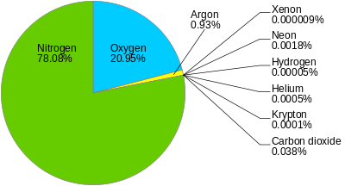](https://en.wikipedia.org/wiki/File:Atmosphere3.svg)**

**Oxygen**

The presence and proportion of oxygen in air can be determined by burning certain metals, example, copper, lead and magnesium in air. The oxygen of the air combines with these metals to form oxides, which are greater in masses than the pure metals.

The difference in mass is the oxygen present in the volume of air used - this procedure can be employed to estimate the volume of oxygen in the air. The equations for the chemical reactions are:

2Cu(s) + O2(g) → 2CuO(s) Copper(II) oxide

2Pb(s) + O2(g) → 2PbO(s) Lead(II) oxide

2Mg(s) + O2(g) → 2MgO(s) Magnesium oxide

Phosphorus can also be burnt in a measured volume of air to obtain by volume the proportion of oxygen in air. The equation of the reaction is:

P4(s) + 5O2(g) → P4O10(s) Phosphorus(V) oxide

For convenience, white phosphorus is used. White phosphorus catches fire very easily (for this reason, it is stored under water). Note: only the oxygen component of air supports combustion, others, i.e., CO2, N2, and water do not.

To obtain a more accurate determination of the proportion of oxygen by volume in air, we can use the smoldering of phosphorus in air, or by passing air into alkaline pyrogallol, or into benzene-1,2,3 - triol, which absorbs its oxygen.

When white phosphorus is exposed to a measured volume of air, it smolders as it absorbs oxygen from the air. The volume of the absorbed oxygen is measured, and the percentage composition is calculated to be about 20.8%. The chemical change that occurs is same with that of the combustion of phosphorus in air:

P4(s) + 5O2(g) → P4O10(s)

When a measured volume of air is passed into alkaline pyrogallol or benzene-1,2,3-triol, only the oxygen component is absorbed. The volume of the absorbed oxygen is measured and its percentage composition can also be determined.

**Carbon(IV) Oxide**

The occurrence of carbon(IV) oxide in air is traceable to the combustion of fuels, e.g. coal, wood, petrol and paraffin - these materials are composed mainly of carbon.

C(s) + O2(g) → CO2(g)

It is also present in the air through the process of respiration – all animals and plants produce CO2 as a by-product of respiration, which is released into the atmosphere. The decay of organic material also releases CO2 into the atmosphere. For the fact that plants require CO2 to synthesis carbohydrates, and also for the fact that CO2 dissolves in the water of the oceans, the percentage of CO2 in air remains constant at 0.03% by volume, in spite of the enormous amount produced into the atmosphere.

The presence and proportion of CO2 in the air can be determined by passing a measured volume of air into a solution of calcium hydroxide (also called lime water). Calcium hydroxide solution absorbs CO2 in limited amount to give white precipitate of CaCO3, and in excess amount to give a milky appearance.

Ca(OH)2(aq) + CO2(g) → CaCO3(s) + H2O(l)

CaCO3(s) + H2O(l) + CO2(g) → Ca(HCO3)2(aq) Calcium hydrogen trioxocarbonate(IV).

The milky appearance is due to calcium hydrogen trioxocarbonate(IV), Ca(HCO3)2 produced. The volume of CO2 absorbed is measured, and its percentage composition calculated. Other substances that can be used to absorb CO2 are concentrated solutions of KOH and NaOH (these will produce soluble carbonates with limited CO2 ; and hydrogentrioxocarbonate(IV) with excess

CO2.

Solid NaOH can also be used. Solid NaOH absorbs water from the air to form a solution, which then absorbs CO2 to form sodium trioxocarbonate(IV) decahydrate. The decahydrate loses 9 of its water of crystallization, absorbs more CO2 and forms sodium hydrogen trioxocarbonate(IV).

2NaOH(s) + 9H2O(l) + CO2(g) → Na2CO3.10H2O(s)

Na2CO3 .H2O(s) + CO2(g) → 2NaHCO3(s)

**Water Vapor**

The evaporation of water from oceans, rivers, lakes etc, produces the water vapor of air. Its presence and proportion in the air can be found by passing a measured volume of air through some substances which absorb water, such as anhydrous calcium chloride and conc. tetraoxosulphate(VI) acid.

In a day or two, a solution of the compound will be obtained, while the volume of air decreases. The volume of water vapor thereby absorbed is measured, and its percentage composition calculated - the results vary from place to place. Nitrogen Nitrogen is almost inert; therefore, there is no suitable chemical procedure to test it in the presence of the other components.

Hence, the other components are usually removed from the air, leaving behind nitrogen for complex test procedures. The following is a procedure to separate nitrogen from air: A given volume of air is passed through a deliquescent substance to remove water vapor, after which, it is passed into a solution of slaked lime, i.e. calcium hydroxide, where the CO2 component is absorbed.

It is moved onto a furnace where the oxygen component burns copper to give copper(II) oxide. The gas left after this process is mainly nitrogen, which is not removed by any known chemical method.

Note: * The presence of the noble gases in atmospheric nitrogen makes it denser than pure nitrogen obtained from its compounds. In the industry, either nitrogen or oxygen is obtained from liquid air (containing mainly oxygen and nitrogen) by fractional distillation. Nitrogen boils at 77 K, argon which is the major noble gas in the air boils at 87 K, while oxygen boils at 90 K.

* By fractional distillation, pure nitrogen is obtained.

**Air Impurities or Pollutants**

Air, especially in the industrial areas contains certain particles, which pollute it. These include hydrogen sulphide (H2S), sulphur(IV) oxide (SO2), the oxides of nitrogen, carbon monoxide (CO), dust and other solid particles such as lead. An evidence of these pollutants in the air is the tarnishing of silver- this is due to the presence of H2S, which forms a black layer of silver sulphide on the sliver.

**FLAMES**

Flames occasionally flicker and dance over the surface of a burning coal fire, but most of the time the fire is flameless, illuminated only by the glow of burning solids. The flames leaping from it are areas in which gases are burning. When they burn, these gases combine with the [oxygen](http://www.daviddarling.info/encyclopedia/O/oxygen.html) in the air and in doing so, [heat](http://www.daviddarling.info/encyclopedia/H/heat.html) and [light](http://www.daviddarling.info/encyclopedia/L/light.html) are given out making the flame hot and often visible.   
  
If a gas will burn, then it always burns with a flame. For example, the gases [carbon monoxide](http://www.daviddarling.info/encyclopedia/C/carbon_monoxide.html) and [hydrogen](http://www.daviddarling.info/encyclopedia/H/hydrogen.html) always burn with flames, carbon monoxide with a bright blue flame and hydrogen with a paler blue flame. But there is no hard and fast rule for solids. Some burn with flames; others do not. When hot iron filings are lowered into a jar of oxygen, they burn with a dull glow, but not with a flame. In contrast under similar conditions, warm yellow [phosphorus](http://www.daviddarling.info/encyclopedia/P/phosphorus.html) will burst into flame and cannot be made to burn flamelessly. If the temperature is raised sufficiently for the solid to vaporize, it burns with a flame as the vapor catches fire. If no vapor is given off then there can be no flame. Volatile substances burn more often with flames than non-volatile substances.   
  
To get a piece of paraffin wax to burn with a flame it must be heated quite strongly. But if a wick is inserted to make it a candle, no such strong heating is necessary. When a match is applied, some of the wax melts, and it is drawn up the wick by [capillary action](http://www.daviddarling.info/encyclopedia/C/capillary_action.html). The tip of the lighted wick becomes incandescent and the heat generated causes some wax to vaporize and catch fire. More wax rises up the wick to take its place.   
  
Before any gas or vapor can burst into flame a certain temperature must be reached. The lowest temperature at which the substance will take fire is known as the **ignition temperature**. The ignition temperature is not a fixed value for a particular gas for it varies with the conditions. Gas pressure and the presence of catalysts can affect it. At very low pressures, gases are more difficult to set alight because the ignition temperature is much higher. For flammable liquids this temperature is known as [flash point](http://www.daviddarling.info/encyclopedia/F/flash_point.html)est temperature at which the liquid gives off a vapor that will burst into flame

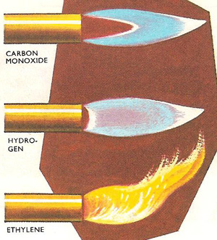

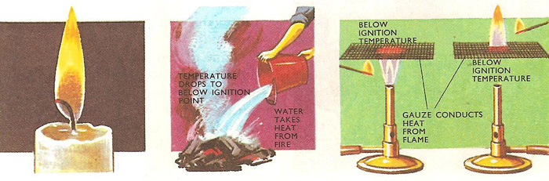

When a piece of metal gauze is held above a [Bunsen burner](http://www.daviddarling.info/encyclopedia/B/Bunsen_burner.html) and a lighted taper is applied below, the flame is stopped by the gauze because the metal conducts the heat away, preventing the gas above from reaching the ignition point and so it cannot catch fire. When the experiment is repeated this time by applying the flame above the gauze, for the same reason, only the gas above the gauze catches fire. There is no flame, only unburned gas beneath it.

|  |
| --- |
|  |
|  |

Flames differ in appearance. There are several reasons for this. The flames may have different structures. Apart from at the center, a candle flame appears uniformly yellow throughout; so does a luminous Bunsen flame, whereas a roaring Bunsen flame has an inner blue cone surrounded by an outer transparent cone. All flames also have a central zone of unburned gas at the base. This is quite easily demonstrated by holding a piece of asbestos paper so that it cuts across the lower part of the flame. A hollow ring of soot is deposited by the burning gas or vapor but none by the unburned gases. Holding another piece of asbestos paper vertically in the flame shows the zone of unburned gases to be cone-shaped.   
  
The candle flame and the outer cone of the Bunsen flame are both examples of **diffusion flames** (see [diffusion](http://www.daviddarling.info/encyclopedia/D/diffusion.html)). When the candle is lit, the vaporized paraffin was diffuses out from the wick and mingles with the air needed for its [combustion](http://www.daviddarling.info/encyclopedia/C/combustion.html). The gases which have bee only partly burnt in the inner cone of the Bunsen flame behave similarly, diffusing out to mix with the inward diffusing air.   
  
The inner Bunsen cone is an explosion of traveling flame. If a match is applied to one end of a tube of coal gas, the gas catches fire at that end and the flame travels along the tube, as each successive layer of gas is burnt.   
  
The blue cone is a flame of this type, only the gas issuing from the Bunsen is not stationary. The rate at which the flame travels down through the gas is balanced by the rate at which more gas issues from the burner to take its place. As the two balance, the flame appears to be stationary. The traveling nature of the flame can be further demonstrated by turning down the gas supply. Then the flame travels down into the burner faster than the gas can come out and the Bunsen lights at the bottom. This is known as striking back. The Bunsen should never be left to burn with this sort of flame as the bottom of the burner becomes overheated. Also the gas is only partially burned and the poisonous gases escape into the atmosphere.

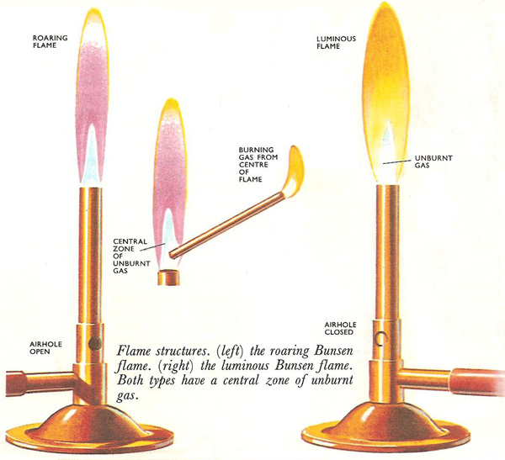

As for the Bunsen flame, flames of other burning substances can have various cones or mantles. The flame of burning [ammonia](http://www.daviddarling.info/encyclopedia/A/ammonia.html) consists of three different colored mantles or cones, an inner cone of unburned gas, a yellow middle cone, and an outer mantle of yellowish-green flame. The flame of burning carbon monoxide is bright blue, and a candle flame, bright yellow. The different colors of flames are caused by the different chemical reactions taking place within them. If a flame has three mantles, then there are three different chemical reactions taking place, one in each mantle. Certain substances in the flame give out light colors. If the reaction produces fragments consisting of a [carbon](http://www.daviddarling.info/encyclopedia/C/carbon.html) atom bonded with a hydrogen atom, violet light is given out. The presence of two bonded carbon atoms tinges a flame green. Carbon particles give out red or white light.   
  
No completely satisfactory theory has yet been put forward to explain the luminosity exhibited by some flames. At one time it was thought that the luminous flames had solid particles suspended in them. But it has been proved that although many luminous flames do contain particles of solid, this is not always so. It has also been suggested that with hydrocarbon flames the luminosity is caused by dense hydrocarbons rather than solid particles.

**Cool flames**

The mind automatically associates flames with heat, but some are actually quite cool. Over a pressure range, particular mixtures of vapor and air give flames which are comparatively cool, with temperatures around 300°C, compared with normal flame temperatures of over 1,000°C. Variation of composition or pressure may give rise to a normal flame or to an explosion. Naturally explosive mixtures must be avoided in car cylinders.

**Bunsen Burner and Types of Flames**

|  |
| --- |
| Bunsen Burner is still used today as it safely burns a  continuous stream of a flammable gas like natural gas, etc.  The amount oxygen mixed with the gas stream determines whether the combustion is complete. Less air makes an incomplete and thus cooler reaction, resulting in a luminous flame. While a gas stream is well mixed with air creates a more complete and hotter reaction the non-luminous flame due to more oxygen available.   * Luminous flame is formed when the airhole is closed thus the gas will only mix with surrounding air at the point of combustion at the top of the burner and is yellow due to an incomplete reaction. It is also caused by the small soot particles which is carbon in the flame. * Non-luminous flame is formed when the air hole is partially open and is less visible to the backgrounds. The hottest part of the flame is the tip of the inner flame, while the coolest is the whole inner flame. The non-luminous flame is due to the sufficient air flow when the air hole is partially open and that cause a complete combustion * Strike back occurs when there is too much oxygen and create a green flame at the jet of the Bunsen Burner and creates a loud noise. This only occur when the air hole is fully open.   Bunsen burner parts :)   The air flow can be controlled by opening or closing the slot openings at the base of the barrel, the collar. |

**[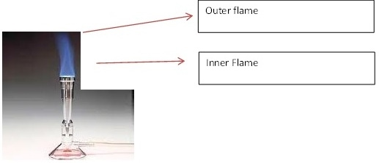](https://sites.google.com/site/samuelscienceeportfolio2/term-1/bunsen-burner-and-types-of-flames/asdsad.jpg?attredirects=0)**

**QUESTIONS**

**1.What happens when air is passed over alkaline pyrogallol.**

**2.State the constituents of Air and their percentage composition.**

**3.Describe the types of flames you know.**

**4.Describe an experiment to determine the composition of Air.**